AES Encryption Databus Unit with USB Protocol

Design Review Document

Submission Date: 5/2/2018

Thursday 11:30 Lab (Lab Section 4)

Teaching Assistant: Mochen Linghu

**Prepared by:**

Da Cheng, Benjamin Parker, Joe Trichak, Zihan Wang

**1. Executive Summary**

Information protection and security have become priorities for companies, political parties, and government agencies around the world due to the threat of a compromised security system. Stolen information can be very costly to all of the aforementioned parties. One system for protecting data is encrypting it against a key to protect its real contents. Encryption of vast amounts of information can take exhaustive amounts of time and requires a high amount of computational power. These specifications make an encryption ASIC a great solution. An ASIC can be customized to perform these calculations operating at rapid speeds with little power consumed in the process.

The design also expands flexibility in operation by utilizing a USB protocol to change the direction of information and permit external input or feedback loops in the design. Each step of the process is isolated by the main controller unit to prevent overlapping data or impromptu transitions. The encryptor and decryptor will each have their own cores for performing transformations on the data and memory for storing data after transformations.

Successful design of the proposed encryption bus will require the following resources:

* USB 1.1 standard documentation
* Reference Standard Cell Simulation Library for Mapped Design Verification
* Reference Standard Cell Technology Library for Final Design Layout Verification
* Verilog HDL Simulation and Design Synthesis Tool Chain
* Sample KAT (Known Answer Test) Vectors for Algorithm Validity

The following document contents will describe:

* Intended usage expectations and constraints for the design, in brief. (Section 2)
* Intended main implementation architecture. (Section 3)
* Intended design success criteria. (Section 4)
* Intended design verification. (Section 5)
* Project Responsibilities by team member (Section 6)
* Appendix of Files (Section 7)

**2. Design Specifications**

**2.1 System Usage**

**2.1.1 System Usage Diagram**

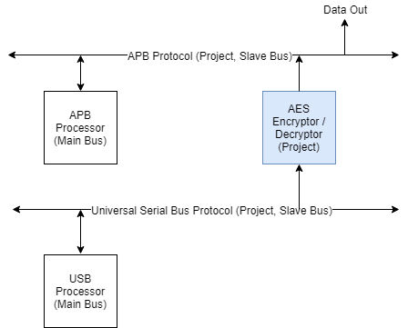

*Figure 1: Example System Usage Diagram for AES Encryption Unit with USB Protocol*

The system above, Figure 1, depicts a sample illustration of the proposed AES Encryptor. The system has a Main Processor to give instructions to the design and a buffer controller to interface with the buffers that will store the results of encryption and decryption calculations. A full cycle of operation for the encryption bus is as follows:

1. Verify validity of data with token packet and CRC error checking
2. Receive operation and determine following steps by op code
3. Encrypt -
   1. Store data in a temporary register
   2. Encrypt data against user input key
   3. Store result in Encryption registers
4. Decrypt -
   1. Store data in a temporary register
   2. Decrypt data against user input key
   3. Store result in Decryption registers
5. If a CRC check determines there is an error, throw out data from the respective buffer

**2.1.2 Implemented Standards and Algorithms**

* **Universal Bus Protocol 1.0**
  + 64-bit data bus
  + Bit-stuffing
  + 16-bit CRC for data packets
  + 5-bit CRC for token packets
  + Read and Write operations
    - Token packet specifies in/out
    - Following data packet specifies operation (Encryption / Decryption)
  + 12-Mbits/s (Full Speed)
* **Advanced Encryption Standard**
  + 256-bit Key Rijndael Encryption standard
  + Uses Rijndael standard S-box as byte substitution lookup
* **APB Protocol**
  + Simplified bus protocol used to read out data or write in key
  + Allows user interaction for reading data out of slots
  + One bit select line (1 for encryption buffer, 0 for decryption buffer)
  + Read enable line has priority over writing

**2.1.3 Encryption/decryption address mapping**

|  |  |  |  |
| --- | --- | --- | --- |
| **Address** | **Read/Write** | **Data Size (Bits)** | **Description** |
| Data In Buffer  0x000 -> 0x080 | RW | 128 | The address of the buffer that stores data to be encrypted and is also read out to the user |
| Encrypt Buffer  0x100 -> 0x180 | RW | 128 | The address of the buffer that stores data to be decrypted and is also read out to the user |

*Table 1: Encryption Local Address Mapping*

**2.2 Design Pinout**

|  |  |  |  |
| --- | --- | --- | --- |
| **Signal Name** | **Type (In/Out/Bidir)** | **Number of Bits** | **Description** |
| nRst | In | 1 | Asynchronous Reset (Active Low) |
| VCC | PWR | --- | Power Pin |
| GND | GND | --- | Ground Pin |
| clk | In | 1 | System Clock (100MHZ) |

*Table 2: Miscellaneous Pinout Table*

|  |  |  |  |
| --- | --- | --- | --- |
| **Signal Name** | **Type (In/Out/Bidir)** | **Number of Bits** | **Description** |
| d_plus | Bidir | 1 | Logic positive of the input data |
| d_minus | Bidir | 1 | Logic negative of the input data |

*Table 3:USB Protocol Mapped Interface Pins*

|  |  |  |  |
| --- | --- | --- | --- |
| **Signal Name** | **Type (In/Out/Bidir)** | **Number of Bits** | **Description** |
| read_enable | In | 1 | When high, the data from the buffer is to be read |
| Pselect | In | 1 | Selects the buffer (Enc v Dec) to be read (0: 0x000 - 0x080 / 1: 0x100 - 0x180) |
| read_out | Out | 32 | Encrypted/Decrypted data shifted out 4 bytes (LSB first) at a time after a successful out operation received |
| key_in | In | 32 | Key input from the user - fed in from LSB to MSB. User must change inputs every 2 clock cycles to successfully write in key |
| write_enable | In | 1 | Indicates there is a read request on the APB protocol - 2nd highest priority behind read |

*Table 4:APB Protocol Mapped Interface Pins*

**2.3 Operational Characteristics**

**2.3.1 Top Level Operation**

Normal top level operation of the design is as follows:

1. If an APB read-out request is made, look at the select line IO and read out data from the appropriate buffer in 32-bit cycles
2. If an APB write-in request is made, write in data from the key input 32 bits at a time to the key register
3. If no APB requests are made, check the D+ input for an edge (start of transmission). If no edge detected, repeat 1-3 until edge/request is detected
4. If an edge is detected, read from USB protocol for the token packet
5. Enable the CRC-5 module to determine if the token packet was read correctly, and if not so, assert the error flag and wait for EOP signal
6. Read in the operation code packet to determine if the following data is data for encryption or decryption
7. Tell the MCU which operation to perform based on the operation code read from the op-code byte
8. Enable the CRC-16 module to determine if the data was read correctly, and if not so, assert the error flag and start over. If data was stored at any point, clear the appropriate register
9. Perform the encryption / decryption on the packet based on the current key in the key register
10. Store the result of the encryption / decryption to specific buffer, go to step 1

**2.3.2 USB Protocol / Packet Content**

Our USB protocol will only be responsible for receiving data from the processor and sending them to the appropriate registers based on the packet ID and write op byte in the data sequence.

For a valid transmission, the following order is defined with preset values.

The token packet is 35 bits long consisting the following fields: 8 bits for sync, 8 bits for PID, 7 bits for the address, 4 bits for the endpoint, 5 bits for the CRC-5 verification, and 3 bits for the end of operation code. The valid PID values are specified below in Figure 3, while the address and endpoint fields will be a constant 0. The functionality for these fields are not used due to having them specified in the data and token packets.

The data packet is 175 bits long in this design, consisting of 8 bits for sync, 8 bits for PID, 8 bits for the op code, 16 bytes (128 bits) for the data packet, 16 bits for the CRC-16 verification, and 7 bits for the end of operation code. The op-code specifies what values of transmission are valid for the data packets of each section. After decoding the op code packet, the following values determine what operation will happen next:

11111111 - The following data is 16 bytes long, which contains 128 bits of data to be sent for encryption.

00000000 - The following data is 16 bytes long, which contains 128 bits of data to be sent for decryption.

In Figure 2, the diagram shows the general sequence of events in each type of operation with perspective from the host device. It is important to note that the clock cycles for the token, write op, etc. fields are not accurate since they are bytes long and need many more cycles to be processed.

The handshake packet consists of 19 bits: 8 bits for the sync byte, 8 bits for the packet ID (00101011), and 3 bits for the EOP signal. This packet is only transmitted to follow the protocol, but does not contribute anything to the procedures of the device.

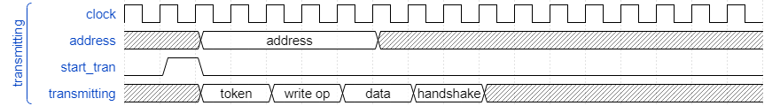

*Figure 2: Receiving / Transmitting waveforms of the USB protocol*

After receiving and pre-processing all the data packets, the type of operation is determined by the PID bits and sent to the MCU, and the data bits received are stored in the specific buffer, waiting to be encrypted or decrypted.

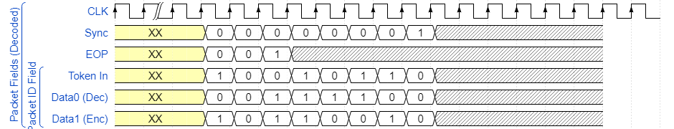

*Figure 3: Common packet values for fields in data, token, and handshake packets (Decoded)*

In Figure 3, default values are given for certain types of fields in packets. Data 0 (Dec) indicates the data packet is for decryption, while Data 1 (Enc) indicates the data packet is for encryption. These PID values must also be checked with the operation type specified by the operation data packet, and an error must be generated if they do not match. The token in field is by default used, since only inward data will come from the USB host.

**2.3.3 Cyclic Redundancy Check (CRC)**

The AES encryption data bus unit using USB protocol design implements two standard Cyclic Redundancy Check (CRC) error detection codes to validate specific user input packets (CRC5 for the token packet and CRC16 for the data packet). The CRC is based on a generated polynomial for each specific standard which is used in polynomial division to determine a remainder which will be used in a comparison later (CRC16 - $x^{16}+x^{15}+x^{2}+x^{0}$/ CRC5 - $x^{5}+x^{2}+x^{0}$). Initially, data that is being input is run through the CRC and produces a remainder. Then, once the data is received, it is run through the same generated CRC and calculate the remainders of the two cycles. If the remainders in the second cycle are all zeros, the data transfer was a success, if not, there was an error during the transfer.

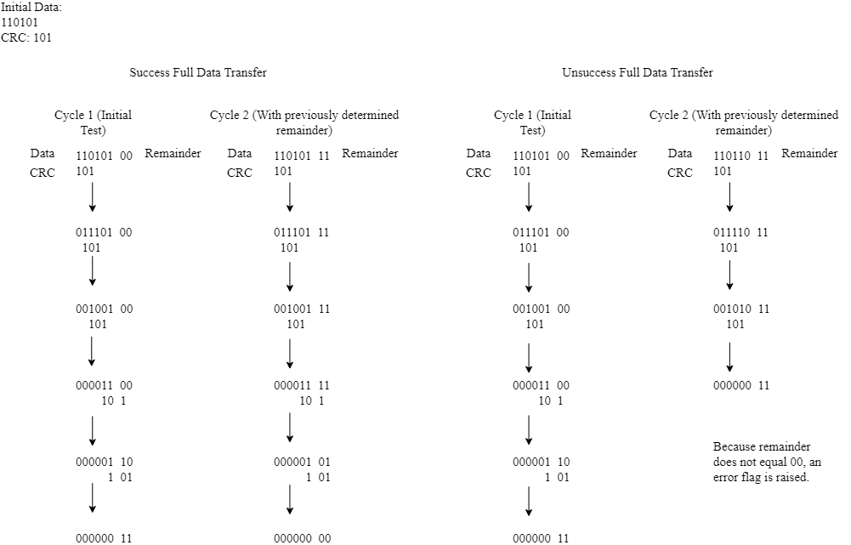

*Figure 4: CRC visual representation of the cycle*

Figure 4 demonstrates how a CRC (in this example CRC5) is used to compare data. The data being compared is set into two components – the actual data (in the example, eight bits) and the remainder (in the example, four bits). The number of bits in the remainder is determined by the number bits in the specific CRC standard; number of bits in the CRC minus one. In the example, the CRC has three bits so the remainder will have two bits. From here, the most significant bit of the CRC is matched with the highest significant bit of the data that is the equivalent – since CRC’s most significant bit is a 1, it must be matched to the 1 with the highest significance in the data. Then an XOR operation is performed between the CRC and the data based on the position of the most significant bit of the CRC. Eventually, the CRC will overlap the data into the remainder. Continue the XOR comparison and shifting of the CRC until every value in the dividend (not the remainder) is set to zero. This resulting remainder will then be used as the expanding numbers for the dividend in the second cycle. If the remainders are all zeros in the second cycle, the data transfer was a success,

The Successful Data Transfer example demonstrates a successful CRC validation, and the Unsuccessful Data Transfer example demonstrates an unsuccessful CRC validation due to noise/improper data transfer.

**2.3.4 AES Encryption Procedure**

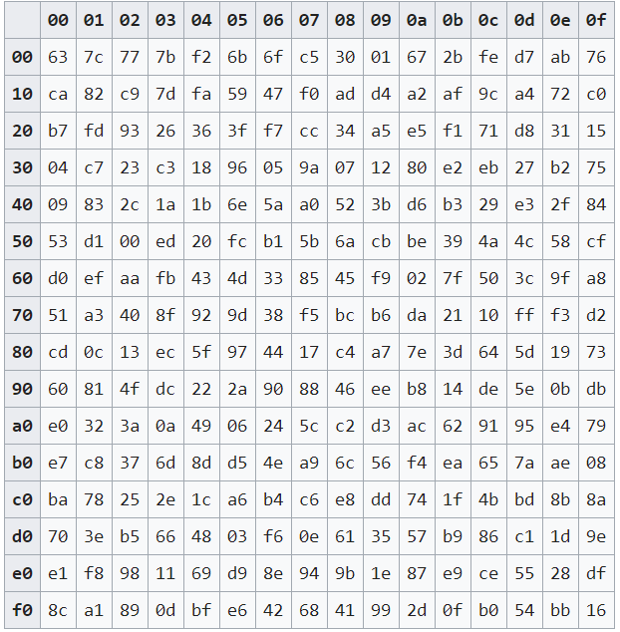

*Table 5: Rijndael’s S-box used for byte substitutions (apprize.info, 2016)*

A normal operation in encryption is as follows:

1. The 128 bit input is entered into block and partitioned into bytes, then into 4 byte “rows”
2. Each byte is added by a corresponding value in the key word generated by the key expansion block
3. The bytes are then substituted using Rijndael’s S-box, shown in Table 4
4. Each transformed byte is rerouted in the shift rows stage
5. The columns of each row are then multiplied by a constant matrix in the multiply rows stage
6. Each byte is added again by a corresponding value in the key
7. Steps 3-6 are repeated 12 more times to get through 13 rounds
8. Steps 2-4 are repeated for round 14
9. The final bytes are added with the key before completing the process

**2.3.5 Bit stuffing**

Bit stuffing is the process of inserting a set bit (generally 0) representing empty data into the data stream for the purposes of filling buffers or frames to the correct size, or to ensure the correct bit rate is being transmitted. In USB protocol, bit stuffing is used to create additional data signal transitions to guarantee reliable reception - specifically to ensure the bus is toggled at a minimum frequency - or to avoid specific sequence codes. In general usage of bit stuffing, the stuffing bit is added after five successions of the same bit, but for USB 1.1, the stuffing bit (in this case a 0-bit) is specified to be added after six successive 1-bits.

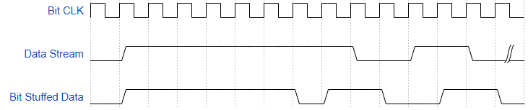

*Figure 5: Bit Stuffing Waveform Example*

Figure 5 shows an example of how the USB bit stuffing works. The clock (which every cycle represents one bit, not one clock cycle) registers six consecutive 1-bits in a row and the device then places a stuffing bit after the six 1-bit before continuing through the rest of the data.

**2.3.6 APB Protocol**

The APB Protocol will be a simplified version of the actual APB protocol. This protocol will act as a two-sided 32-bit protocol. All read requests are treated with priority over writing commands (although if a process is active, the read requests will be ignored to avoid fighting for the address pointer of the buffers). Any read request will be considered a valid read, even if the buffers have no data stored within them, in which case 32 bit sequences of 0 will be read out. Once toggled, the APB protocol will read out data from the Encryption buffer if the select line is asserted or from the Decryption buffer if negated. The process will take routing control over the buffer and operate in a cyclic manner as follows:

1. This state will set up the address to be input to the buffer block (0, 32, 64, 96) as well as all of the other signals.
2. The read enable signal will be asserted here, and the buffer block will cycle out the respective data in each address out, which will feed out of the APB protocols read-out port

This process will continue for 8 cycles (4 setup cycles, 4 readout cycles) and wait until another read is requested.

If the read request line is low, but the write-request line is high, this indicates that the user wishes to place a new key for the AES modules. This procedure will follow the same cyclic sequence as the read-out for the APB, but it will take 8 sequences instead of 4 to accommodate the 256-bit key length. However, this will simply clock in the key 32-bits at a time into the key register in the top-level module.

When both request lines are low, the APB protocol remains in an idle state, and so long as the MCU is performing an ongoing action elsewhere, will remain so until the MCU sends the necessary signals to the APB for operations.

**2.4 Requirements for the design**

For the implementation of an AES encryption device using USB protocol, there are many constraints to consider while ensuring the device works correctly. The target speed for the application of the device is to match the standard full speed USB protocol of 12Mbits/s. Along with this necessary processing speed for the data, the device also needs to ensure that the encoding or decoding is completed faster than the packet data is read to prevent any possibility that multiple data packets are handled simultaneously. To reach the standard full speed USB protocol, a 96MHz clock was chosen as this is a commonly used standard clock speed for USB 1.1 protocol.

This device will attempt to minimize the area of our AES calculation by serializing each round and clocking the end result 14 times for 14 rounds. To verify that it meets the throughput requirements, the following calculation was made based on our longest delay path (AES decryption, normal stage):

$128 bits ÷ 1 decryption process$

$(1 round Dec ÷ 10.416 ns (Clock period)) × (1 decryption process ÷ 14 round Dec)$

$= 0.006857582 decryption process / ns$

($128 bits ÷ 1 decryption process) ×(0.006857582 decryption process / ns)$

$= 0.877770463 bits / ns = 877.770463 Mbits / second >> 12 Mbits/second$

Since the throughput of our longest AES module is well within the throughput of the full-speed module, this serialization is valid to conserve our area usage.

While parallel operations will increase the size of the board usage initially, a combination of multiplexers and a counter will allow the same parallel set of gates for each of the fourteen rounds of encryption and decryption. Overall, this will greatly decrease board size while simultaneously optimizing the speed of the encryption and decryption. For our core size (no IO pads), the target area usage is a 4mm x 4mm design. This is due to the large area we will use for performing the AES encryption and decryption calculations. Since those portions are implemented using primarily combinational logic, they will require a large amount of area to speed up the calculation. Including IO pads, the area usage will be around 5mm x 5mm due to being very close in terms of combinational usage as well as spacing for even IO pads, especially considering the few usage of IOs and the need of even spacing for our board.

**3. Design Implementation**

**3.1 Design Architecture**

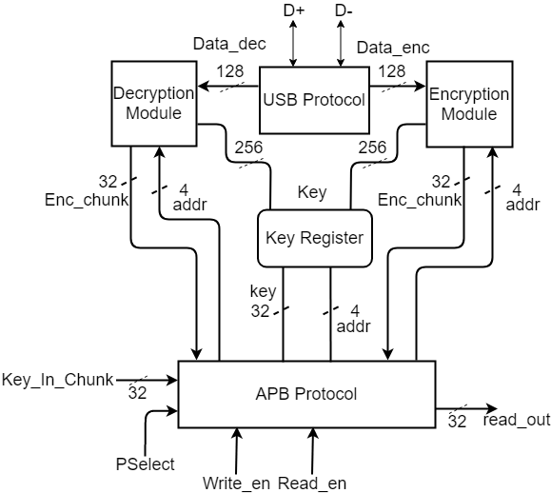

*Figure 6: AES Encryption Databus Unit with USB Protocol Architecture Diagram*

The diagram, Figure 6, above depicts the architecture intended for the device. The Universal Serial Bus (USB) Protocol is utilized to handle the transfer of data to and from the device. This protocol is controlled by the Main Control Unit (MCU) - which we omit for ease of reading diagram - to specify the direction and destination of data from external sources, the Advanced Encryption Standard (AES) encryption, and the AES decryption units. The data is initially read in by the protocol and is then sent to a temporary register for either encryption or decryption. Once completed, the MCU will inform the user it is ready to perform another action. The user can read the data out in 32 bit sequences or perform another operation. Because the USB protocol acts as the only way of routing information to other blocks, each process is isolated to ensure proper data encryption and no overlapping in processes.

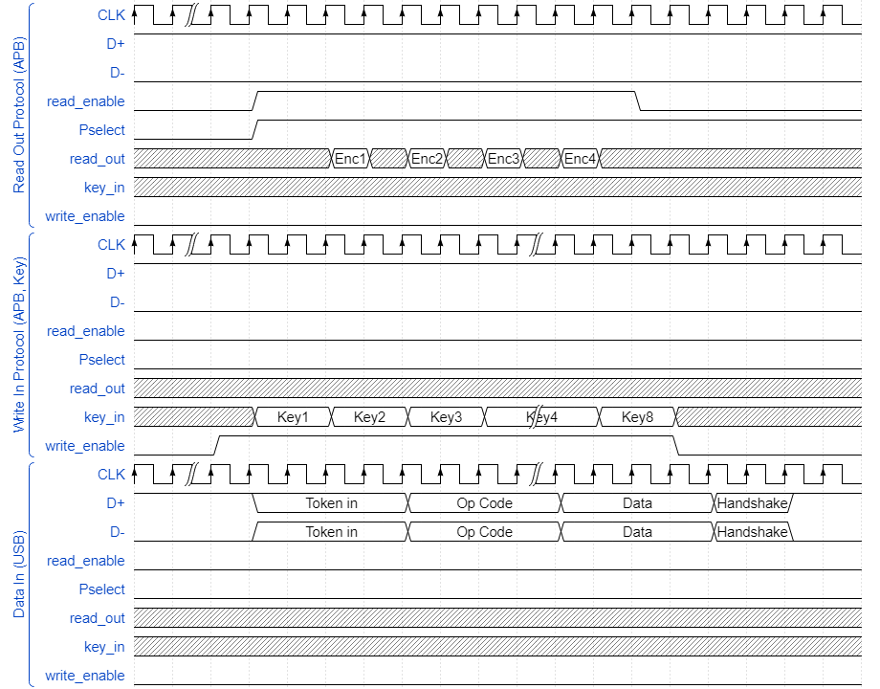

*Figure 7: Architecture Timing Waveform*

Starting with the top protocol (APB read-out request), the read enable is asserted. After one clock cycle, the APB protocol examines the select line to determine what buffer is examined (in this case, the encryption buffer due to assertion). Another clock cycle is taken to set the address for read out, followed by an active read-out cycle through the data_out port. This is repeated 4 times, which entails a successful transmission. Read enable has 2 clock cycles to deassert before another read operation is committed.

For the APB write-in request, the write_enable signal is asserted and the read_enable is deasserted. This informs the top level to shift in the current key input. After a cycle of setup, an active write in signal clocks in the current 32-bit key input to the address. The address is incremented in the following setup phase, thus giving the user 2 clock cycles to change the key input before clocking it in again to the next index of the key register. This process is performed 8 times before a valid write-in transmission is concluded. The user then has 2 clock cycles to deassert the APB write_enable signal before another write_in transmission is performed.

The last valid transmission is a USB protocol read in for incoming data to be encrypted or decrypted. The valid transmission consists of a valid token packet, an op code indicating the destination of the data, a valid data packet, and a valid handshake packet. Any errors in these will cause an error. The above cycle only shows the order of the transmission, since the bit times for the USB protocol are expanded over 8 clock cycles. The packet specifications are given in the USB protocol specification in **Section 2.3.2**. After receiving a valid transmission, the data is stored in an input register to the proper procedure and the encrypt/decrypt process begins. The CRC module is checked, and upon an error, will clear the output of those processes. Otherwise, it will store the result in the appropriate buffer.

|  |  |
| --- | --- |
| **Module (Pg #)** | **Area** ( ${mm^{2}}^{})$ |
| MCU (16) | 0.176400 |
| AES Encryptor (22) | 6.166950 |
| AES Decryptor (32) | 6.550350 |
| Encryption Buffer (N/A) | 0.307200 |
| Decryption Buffer (N/A) | 0.307200 |
| Key Register (N/A) | 0.614400 |
| USB Receiver Protocol (42) | 0.40045 |
| APB Protocol (18) | 0.782400 |
| **Total Area with Wiring Overhead** | 15.414550 |
| **IO Pad Calculations** | **Unit Value** |
| **W, H** | 3926.136778 um |
| **IOH** | 300 um |
| **IOW** | 90 um |
| **Total Chip Area** | 23.2915962 mm ^ 2 |

*Table 6: Total Area Budgeting by Module*

Table 6 shows the total area calculation for our devices modules. It is important to note that modules Key Register, Encryption Buffer, and Decryption Buffer calculations are not further explained as these modules designs are self explanatory; all being forms of storage through registers. As such, they can be calculated using the assumed size of a flip flop with a reset (1600 micrometers squared) and the number of bits being stored. The buffers each store 128 bits, whereas the key register stores 256 bits. Overall, this calculation includes the wiring overhead (each component was calculated including the wiring) and should be a solid approximation of the area necessary for our functional device. The breakouts of each modules’ area (excluding the three mentioned earlier) can be seen in their respective implementations.

The IO Pad calculations are also within the target area calculation for 5x5mm in regards to framing. The core area of 4x4mm also is met with this design. Note that the model used for calculating the IO area accounts for the small IO count on our chip. However, area targets of 18 mm^2 and 27 mm^2 were approved for targets due to added storage used for the key expansion protocol.

**Actual Area: 20,894,598 um^2** (Core area with wiring)

**29,282,386 um^2** (5.440.8 x 5.382 mm)

This area was slightly larger than the final area target of 27 mm^2. This was due to the conservative estimate of 1.5x area coverage for the wiring delay. In addition, there was also additional area that was used for the storage of keys that went unaccounted for the area budget. However, most of the other area was accounted for in the budget. As for the larger IO framed area, this area difference comes from an inability to control the resources used in our design. Rearranging the IO pins did not save much area, hence the larger design needed to fit all of the resources of the design. Altering the row density only caused issues with geometry and connectivity.

**3.1 Functional Block Diagrams**

**3.1.1 Main Control Unit (MCU) State Transition Diagram**

The Main Control Unit (MCU) is used to control the process of dataflow, including choosing between reading data from the USB protocol into the encryption or decryption register, feeding data out to the user via the APB protocol from the respective register, and write the key into the key register via APB protocol. A state transition diagram is shown in Figure 8 below for the MCU.

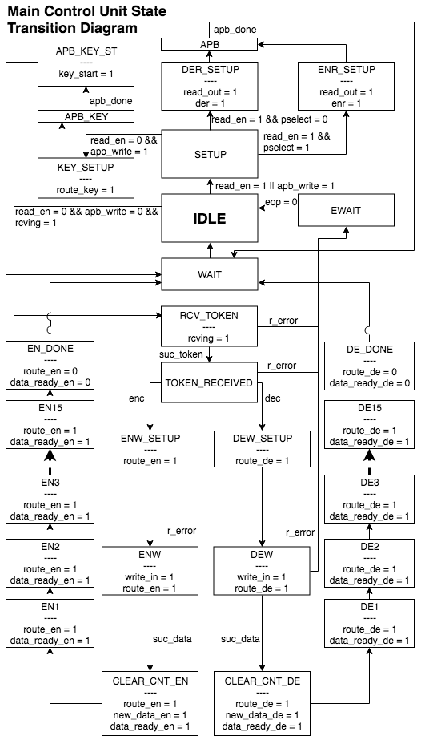

*Figure 8: Main Control Unit (MCU) State Transition Diagram*

On the IDLE state, if the MCU receives the read_en or apb_write signal, it will set up the device for feeding data to the user from the APB protocol or writing the key into the key register via APB protocol. If the read_en signal is high, the MCU reads pselect signal to determine if the data from APB is encrypted or decrypted, and returns to the IDLE state when read is done after waiting for one clock cycle. If the read_en signal is not high, but the apb_write is high, the MCU sets up the APB protocol to write the key into the key register, and returns to the IDLE state when write is done after waiting for one clock cycle.

If the MCU receives the rcving signal while neither read_out signal nor apb_write signal is asserted on the IDLE state, it will set up the device for reading data from the USB protocol. On this route, there are 2 main paths. If the suc_token signal is received, the MCU will enable the write to either the encryption or decryption register. After determine if the data to be written is encrypted or decrypted, the MCU will write the data into the respective register and determine if the data packets have any error. If the data packets have any error, the MCU will wait for the eop signal and then return to the IDLE state after waiting for one clock cycle. If the received data packet has no error, the MCU will clear the encryption / decryption counter and start either the encryption or decryption process. Either of these processes will take 15 rounds, which will be discussed in later sections. After the encryption / decryption process is done, the MCU will go back to the IDLE state.

|  |  |  |
| --- | --- | --- |
| **Module** | **Functional Block (Pg. #)** | **Area** ( ${um^{2}}^{})$ |
| MCU | Finite State Machine | 117,600 |
| **Total Area with Wiring Overhead** | | 176,400 |

*Table 7: MCU Area Budgeting*

Table 7 shows the calculation used to determine the area requirements of the MCU. As this is a finite state machine it is already an RTL and therefore does not have an sub calculations. The calculation is simple for the MCU: for each state that requires a path select, a 1 bit 2-way multiplexer is used, and when the determination requires the input of multiple signals, AND and OR states are used. Each of the multiplexer is estimated to be 1500 um2.

**Actual Area Usage: 94,287 um^2**

This area usage was much smaller than estimated, which could be due to conservative approximations and condensed state registers used to realize the state machine.

**3.1.2 APB State Transition Diagram**

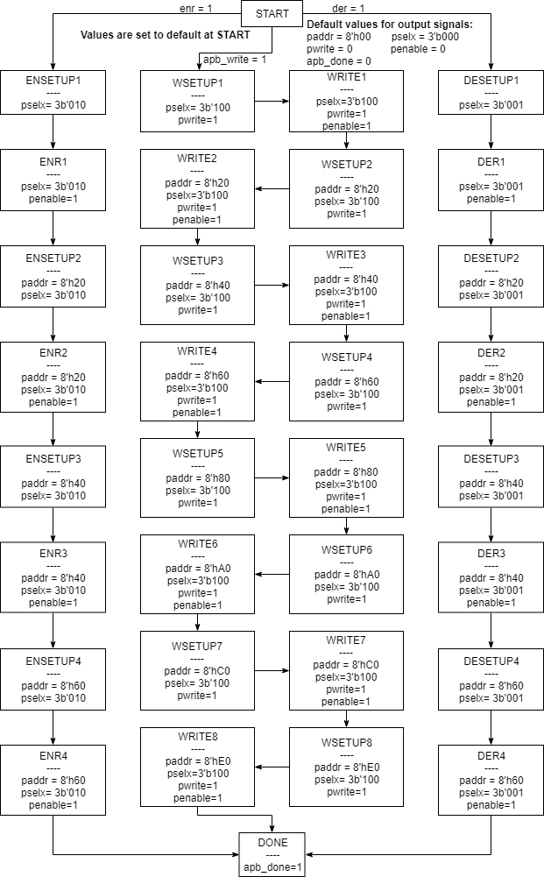

*Figure 9: APB State Transition Diagram*

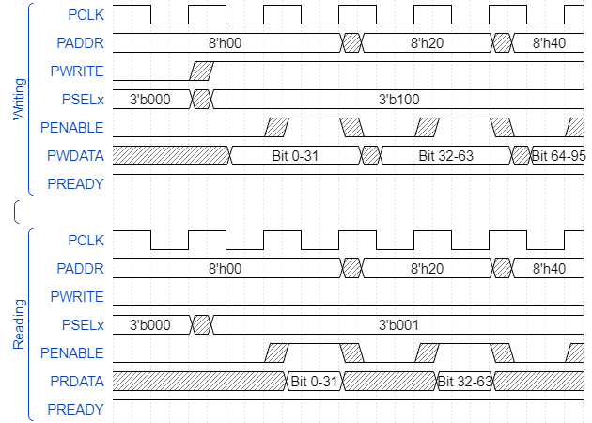

*Figure 10: APB Key Writing and Decryption Reading Out Example*

The APB protocol reads results from decryption or encryption and writes the key to the key registers. Initially, the APB block would receive three signals from the MCU, *apb_write*, *enr*, and *der*, to determine which action to perform. If *apb_write* is received, then the *PSELx* is set to 3’b100, *PWRITE* is asserted, and the key will be written to the key registers, if *enr* or *der* is received, the *PSELx* will be set to 3’b010 or 3’b001, respectively, and the respective encryption or decryption reading will be performed.

For key writing, when *PWRITE* is enabled, each 32 bits of data will be ready at the falling edge of the clock cycle where the address is changed at the preceding rising edge. Then, the *PENABLE* signal is asserted at the subsequent rising edge of the clock cycle, which writes in the data to the key register indicated by *PADDR*. The writing operation repeats 8 times to write in all 256 bits of data. After the key is fully written into the registers, the APB protocol sends *apb_done* signal to the MCU to indicate the operation is finished, and then go back to the *START* state.

For encrypted or decrypted data reading, each 32 bits of data will be read from the current address indicated by *PADDR* when *PENABLE* signal is asserted at the rising edge of the clock cycle. The value of *PADDR* is updated after each reading operation. The reading operation repeats 4 times to read out all 128 bits of data. After the encrypted or the decrypted data is completely read out for the user, the APB protocol sends *apb_done* signal to the MCU to indicate the operation is finished, and then go back to the *START* state.

|  |  |  |  |  |  |
| --- | --- | --- | --- | --- | --- |
| **Module** | **Functional Block (Pg. #)** | **Category** | **SIZE**  **(UM^2)** | **Amount** | **Area** ( ${um^{2}}^{})$ |
| APB Protocol | N/A | 1 bit 2-way Multiplexers | 1000 | 320 | 320000 |
|  |  | Flip Flop with Rest | 1600 | 6 | 6000 |
| **Total Area with Wiring Overhead** | | 489000 (um^2) | | | |

*Table 8: APB Protocol Area Budgeting*

The Table 8 shows the calculation for the area requirement of the APB protocol block. 1 bit 2-way Multiplexers have the size of 1000 um^2 each. Flip Flops with Reset have the size of 1600 um^2 each. APB block has 320 1 bit 2-way Multiplexers and 6 Flip Flop with Reset. The total area of APB block has 326000 um^2.

**Actual Area: 272,173.5 um^2**

This area was slightly smaller due to unnecessary multiplexers in the design. Also, the area representations of our design were conservative estimates, which further explains the difference between the areas.

**3.1.3 AES Encryption Top Level**

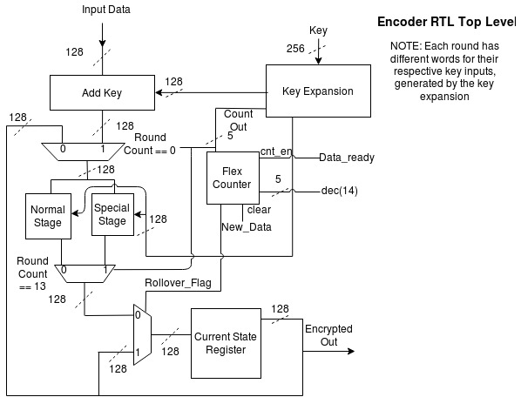

*Figure 11: AES Encryption Top Level Diagram*

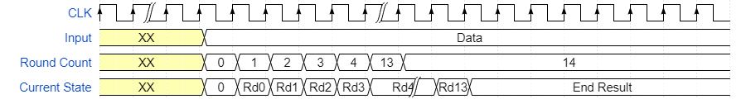

*Figure 12: AES Encryption Top Level Timing Waveform*

The inputs to this top level design are the 128 bits of data to be encrypted and the 256 bit key that comes from the key register. This top level design follows the 256-bit key protocol, which requires 13 standard stages of normal encryption and 1 special stage before completion. In addition, the data must be added with the key (addition here is representative of an XOR operation). Each 128 “key” input to each stage comes from a key expansion function, which generates 128 bit key word sequences following algorithms in the standard so that each input “key” for the add key stages is unique. Following the process, the input data is added with the first “key” word, then input through the stages. Each stage is composed of only combinational logic, and because the goal of this design is to be optimized for speed, each round is left to be purely combinational. However, since the throughput of the USB is easily met by purely combinational processing of the AES, this implementation has a serialized setup that uses the same hardware for each round. The key expansion changes the key input into the stages for each round based on the flex counter. This results in the only significant delay for this portion of the design coming from the gate delay in each combinational logic block for one round. The design’s speed is optimized enough to meet the USB throughput without any problems while minimizing the area used. The round count signals for the flex counters are controlled by the MCU, which allows flexible control of the encryption process.

|  |  |  |
| --- | --- | --- |
| **Module** | **Functional Block** | **Area** ( ${mm^{2}}^{})$ **(W/ Wiring Overhead)** |
| Normal Stage | AES Normal Encryption | 4.128000 |
| Special Stage | AES Special Stage | 0 |
| Add Key | AES Normal Stage | 0.096000 |
| Key Expansion | Key Expansion Block | 0.984000 |
| 1-bit 2-way Multiplexer | N/A | 0.576000 |
| FF w/o Reset | N/A | 0.345600 |
| Flex Counter | Flex Counter | 0.037350 |
| **Total Area with Wiring Overhead** | | 6.166950 |

*Table 9: AES Encryption Total Area Budgeting*

**Actual Area: 5,906,128.5 um^2**

This area was comparably closer to the actual estimate with overhead wiring. However, there were also design changes that occurred that were not accounted for here. For example, an additional S-box was used for the key expansion in this block. Also, multiple multiplexers were used as key word controls for the AES encryption process. However, all of the large gate amounts were calculated using conservative estimates, which kept the area beneath the target.

Most of the design decisions are broken down in their appropriate sub-sections below. There are 256 flip flops without reset, 128 for the current data state and 128 for the current key being fed to the current round. Along with that, 3 128-bit 2-way multiplexers that act as the round control for dataflow in our design. Because of their size, we assumed they used the 1000 um squared large gates on our chip. This allows the isolation of certain parts of the design based on what round it is. For area usage, we have 2 X 128 X 900 um squared X 1.5 for the flip flips, and 3 X 128 X 1000 um squared X 1.5 for the multiplexers.

**3.1.3.1 Timer - Flex Counter RTL**

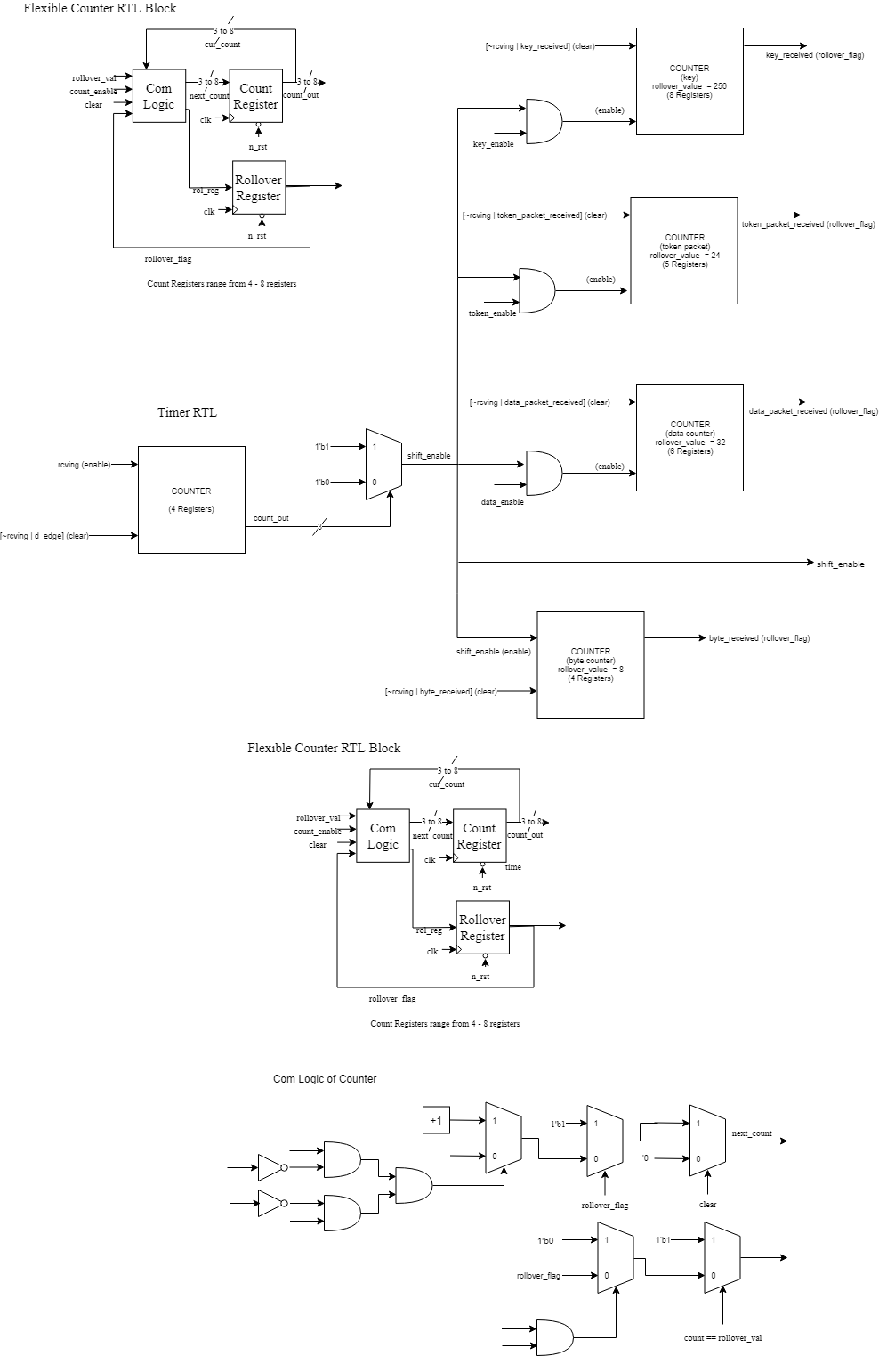

*Figure 13: Flex Counter RTL*

The Flexible Counter is used as a means of counting up to various values based on the number of registers used to store the count value. The combinational logic is split into two sections; one uses a series of selections to determine how the count will be updated and the other to determine how the rollover flag will be updated. For the flexible counter, other than the asynchronous reset, the clear holds the priority for updating the current count. If the clear is high, the count is synchronously reset to zero. The rollover flag holds the next high priority and if it is high while the clear is low and the count enable is high the count is set back to one. If neither the clear or the rollover flag is high and the count enable is high the count is raised by one. If the next count is every equal to the rollover value, the rollover flag register is raised, which in turn will raise the rollover flag with the next clock cycle. The rollover flag and the count out are stored in separate registers that asynchronous reset to zero when the reset is low.

|  |  |  |  |  |  |
| --- | --- | --- | --- | --- | --- |
| **Functional Block** | **RTL Diagram** | **Component Category** | **Size (** | **Amount** | **Area (** |
| Timer | Flex Counter | Gate | 500 | 4 | 2000 |
|  | | 1 bit 2-way Multiplexer | 1500 | 4 | 6000 |
| Flip Flop with Reset | 1600 | 4 | 6400 |
|  | | | | | |
|  | N/A | Gate | 500 | 18 | 9000 |
|  |  | 1 bit 2-way Multiplexer | 1500 | 1 | 1500 |
| **Total Area w/ Wiring** ( ${um^{2})}^{}$ | | 37350 | **Total Area w/ Wiring** ( ${mm^{2})}^{}$ | | 0.037350 |

*Table 10: Timer Area Budgeting*

**Actual Area: 24,894 um^2**

This area was slightly shorter than the estimated area. This difference is most likely caused by the conservative estimates of the gates used in the design.

In Table 10, the area budgeting for the Timer functional block is calculated. For this calculation, it was assumed that the average gate equivalent was 500 micrometers squared, that an inverter is roughly half the area of an average gate, a 1 bit 2-way multiplexer is composed of roughly three gates (and is not being simplified enough to lower the total area as there are a low number of multiplexers being used even though they have constants being fed to some of the inputs), and that a flip flop with a reset has an area of 1600 micrometers squared. The Timer block is made of two components: the flexible counters and the small bits of combination logic between the counters (N/A). The small bit of combinational logic in between the flex counters is just a few AND/OR gates for specific inputs of the flexible counters, a 3 bit comparator for the input of the shift enable multiplexer, and the said multiplexer. Only one flex counter is used to count up to decimal 14, and its clear and count_enable signals are controlled by the MCU.

**3.1.3.2 Normal Encryption Stage Functional Block**

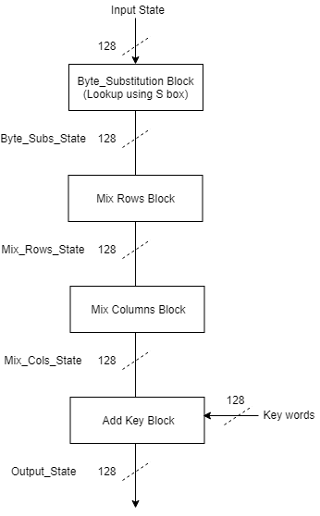

*Figure 14: Normal Encryption Stage Functional Block Diagram*

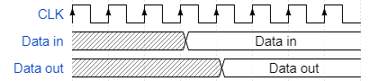

*Figure 15: Normal Encryption Stage Functional Block Waveform Example*

This block shows a normal round of encryption. The input of each stage in AES encryption is called the “input state” and the output the “output state”. For reference, this notation will be used in the document regarding this algorithm. In the AES encryption algorithm, the input data is treated as a 4x4 matrix of bytes and modified in the following order:

The first step is the Byte Substitution. This step will consist of a lookup table that compares each byte in the input data to the standard S-box as described in **Table 4** and mapped to the corresponding byte in the output data. This state is considered the input for the Mix Rows block.

The following step is the Mix Rows step. This step involved a cyclic shift of the bytes in each row of the 4x4 matrix, depending on the row. For example, since the matrix is made of 4 rows, the first row is left unmodified. The second row of bytes is shifted to the left once, the third row twice, and the fourth row three times. This state will flow into Mix Columns block.

The most difficult step of this algorithm is the Mix Columns step. Here, the matrix of bytes is treated as 4 columns instead of 4 rows. Each row is then multiplied by a 4x4 matrix and given a new result, as shown in the following diagram:

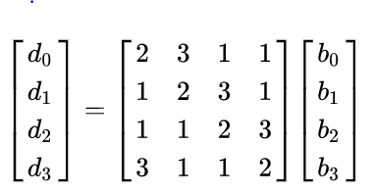

*Figure 16: Diagram of the Visual Representation of the Mix Columns Step*

Here, b0 - b3 represent the operand column of the original 4x4 matrix. The 4x4 matrix which is used for multiplication is also a matrix given by Rjindael’s standard for the Mix Columns step. Each entry in the d column is calculated by the normal method of matrix multiplication. However, the multiplication of 2 and 3 are treated differently.

When an entry of the b column is multiplied by 2, the following operation is executed on that byte. First, that byte is shifted to the left by 1. The MSB of the byte (before shifting is performed) is examined, and if asserted the result of that shift is XOR’d with 0x1B. If it is not asserted, the result is left as is, or can also be XOR’d with 0x00. This is due to the nature of the polynomial math that Mix Columns originates.

Multiplication by 3 is slightly longer, but easy to understand once multiplication by 2 is clear. Here, a byte in the b column is multiplied by 3, written as 3 * b0 for example. However, this same operation can be written as (2 + 1) * b0. This implies that multiplying by three is the same as multiplying by 2, then performing an XOR operation with the original byte on that result.

One sample of calculation is examined for d0. Here, d0 = 2*b0 +3*b1 + b2 + b3. Remembering that addition is simply XOR in this algorithm, the following algorithm (verilog pseudocode) can be used to find d0 :

d0 = (b0 [8] == 1 ? ((b0 <<1) ^ 0x1B) : (b0 << 1)) ^ ((b1 [8] == 1 ? ((b1 <<1) ^ 0x1B) :

(b1 << 1)) ^ b1 ) ^ b2 ^ b3

All columns of the 4x4 matrix are found in this manner, and that output state enters the Add Key step.

In the Add Key step, the input state is added (XOR’d) with the 128 bit “key” bitwise. The output state of this operation is considered the output of 1 round of encryption.

|  |  |  |  |  |  |
| --- | --- | --- | --- | --- | --- |
| **Functional Block** | **RTL Diagram** | **Component Category** | **Size (${um^{2}}^{})$** | **Amount** | **Area (${um^{2}}^{})$** |
| Normal Stage | N/A | 1 bit 2-way Multiplexer (SBox) | 1000 | 2048 | 2048000 |
| Normal Stage | N/A | Gate (Add Key) | 500 | 128 | 64000 |
| Normal Stage | N/A | 1 bit 2-way Multiplexer (Mix Col) | 1000 | 256 | 256000 |
| Normal Stage | N/A | Gate (Mix Col) | 500 | 768 | 384000 |
| **Total Area w/ Wiring** ( ${um^{2})}^{}$ | | 4128000 | | | |

*Table 11: AES Encryption Normal Stage Area Budgeting*

**Actual Area: 3,756,078 um^2**

This area was similar to the calculated area. It could be slightly lower due to conservative estimates used for the gates, as well as slight differences in the wiring overhead.

In the Byte Substitution, a 16x16 Lookup Table is used to substitute byte-wise inputs into their matching indexed outputs. Here, it is assumed that because these multiplexers are a condensed tree, they will use the size of a large gate (1000 squared um instead of 1500) and will only use 16 large multiplexers instead of 16x16. This leads the calculation for multiplexer area to be 16 x 32 x 4 x 1000 um squared.

The Add Key operation uses 128 XOR gates, making the area 500 x 128 um squared.

In the Mix Columns stage, chained multiplexers and XOR gates are used for the polynomial expansions. For every byte of output, the operation has 2x8 1 bit multiplexers, 2 XOR gates with constants, and 6 XOR gates. Therefore, these areas x 16 yields the area consumption of this stage. We assumed that the XOR gates will condense to take ¾ of the area of the expanded operation, leading to 768 XOR gates. Therefore, the multiplexers add up to 2 X 8 X 16 X 1000 um squared, and the XOR gates use 8 X 8 X 16 X ¾ X 500 um squared.

The Mix Rows stage does not use any gate area, since it only consists of rearranging wiring at a byte level.

**3.1.3.3 Special Encryption Stage Functional Block**

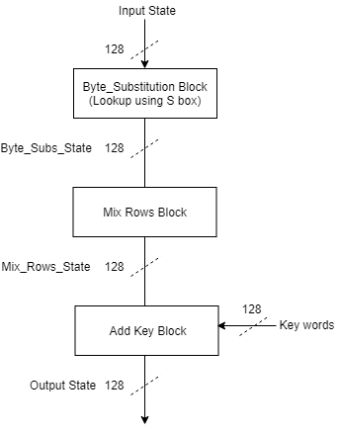

*Figure 17: Special Encryption Stage Functional Block Diagram*

**

*Figure 18: Special Encryption Stage Functional Block Waveform Example*

The functions inside this block perform exactly the same as the normal state encryption block as described in **Section 3.1.3.2**. The only difference in this block is that the Mix Columns step is removed. This stage is also used only as the 14th and final round of encryption before the output is ready.

|  |  |  |  |  |  |
| --- | --- | --- | --- | --- | --- |
| **Functional Block** | **RTL Diagram** | **Component Category** | **Size (${um^{2}}^{})$** | **Amount** | **Area (${um^{2}}^{})$** |
| Special Encrypton | N/A | N/A | N/A | N/A | 0 |
| **Total Area w/ Wiring** ( ${um^{2})}^{}$ | | 0 | **Total Area w/ Wiring** ( ${mm^{2})}^{}$ | | 0 |

*Table 12: AES Encryption Special Stage Area Budgeting*

It may not be apparent from the functional diagram, but for the chip design, the same hardware for the normal encryption stage is used to calculate the special encryption stage. Multiplexers combined with the round counter are used to exclude the Mix Columns stage from the calculation, which mimics the functionality of the special encryption stage. The functional diagram is used to explain conceptually how the process is controlled. This conserves a large amount of area while not compromising performance. These round control multiplexers are present in the top level encryption design.

**3.1.3.4 AES Key Expansion Block**

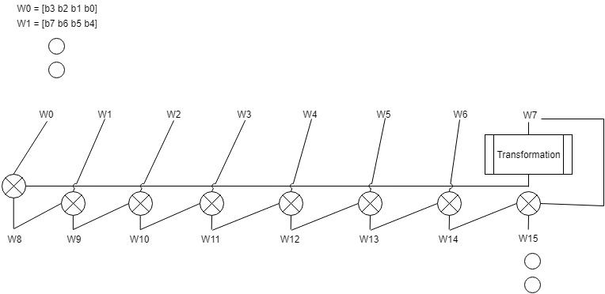

*Figure 19: Functional diagram for Key Expansion*

In both the encryption and decryption algorithms, the Key Expansion block is used to produce independent keys for key addition at every round. Each word Wk is represented by 4 bytes, making each W 32 bits long. The first key addition is done with words W3…W0, and the second with W7...W4. To generate independency from the key, a transformation function is applied to the last word of the key (The most significant 4 bytes). This function includes a byte left rotation, a byte-by-byte substitution using the S-box, and a byte XOR with a round constant. This result is bitwise XOR’d with the matching position of the previous round. In this case, Transform(W7) + W0 = W8. Calculating the words for the same round is simply a bitwise XOR of the previous word and the word matching the position in the previous round. This continues until 8 words in total are generated. These words can carry through for 2 additions, and therefore 2 rounds. To generate 8 more words, the same process is iterated. This block also includes some external controls from the round counter, but overall only implements a few multiplexers and little combinational logic.

|  |  |  |  |  |  |
| --- | --- | --- | --- | --- | --- |
| **Functional Block** | **RTL Diagram** | **Component Category** | **Size (** | **Amount** | **Area (**  **No wiring** |
| Key Expansion | N/A | 1 bit 2-way Multiplexer (SBox) | 1000 | 512 | 512000 |
| Key Expansion | N/A | Gate (Add Key) | 500 | 288 | 144000 |
| **Total Area w/ Wiring** ( ${um^{2})}^{}$ | | 984000 | | | |

*Table 13: Key Expansion Area Calculation*

**Actual Area: 6,221,488.5 um^2**

This area was substantially larger than originally calculated, however there are reasons for this increase. For example, there was around 1.5 mm^2 approved for this segment of the design to have 13 128 bit flip flops with no reset to hold the keys generated by the key expansion process. In addition, another S-box transformation was needed, adding approximately 1 mm^2 to the design. Adding these with the estimates yields around 3.5 mm^2, and with wiring around 5.25 mm^2. This expansion was made larger by multiplexers to change how the keys are stored by the expansion. This would account for most of the large area usage in this design.

For the key expansion block, the XOR gates are used 8 times for the XOR operations between words, along with one extra time in the key expansion. This leads to 288 XOR gates used in the design. The SBox in the algorithm also is reduced to 1/4th size from the normal Sbox due to only operating on 32 bits of data instead of 128. The storing and iteration of the keys are handled in the top level design for the encryption module.

**3.1.4 AES Decryption Top Level**

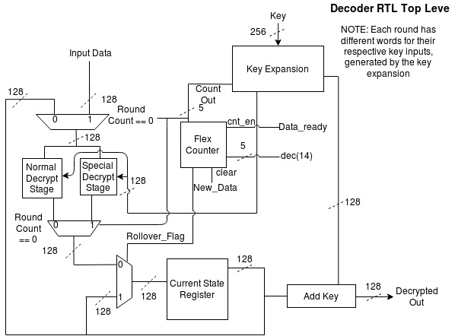

*Figure 20: AES Decryption Top Level Diagram*

**

*Figure 21: AES Decryption Top Level Waveform Example*

The top level of the decryption block serves as the inverse of the encryption in every regard. The blocks behave the same way, except reversed. For example, normally to encrypt input, the input data was added with a key word first. But for decryption, it is added with the key just before finishing the process. Notice that the control signals for the multiplexers (round dataflow control) also changed. This reflects the same for the inverse procedure. In Encryption, the last round of encryption was the special stage. Therefore, for decryption the special stage occurs first (Round count == 0 in Decryption vs. 13 for Encryption). The stages are also inverted, and their operation will be described in the individual stage diagrams.

|  |  |  |
| --- | --- | --- |
| **Module** | **Functional Block** | **Area** ( ${mm^{2}}^{})$ |
| Normal Stage | Normal Decryption Stage | 4.512000 |
| Special Stage | Special Decryption Stage | 0 |
| Add Key | Normal Decryption Stage | 0.096000 |
| Key Expansion | AES Key Expansion | 0.984000 |
| 1-bit 2-way Multiplexer | N/A | 0.576000 |
| FF w/o Reset | N/A | 0.345600 |
| Flex Counter | Flex Counter | 0.037350 |
| **Total Area with Wiring Overhead** | | 6.550350 |

*Table 14: AES Decryption Total Area Budgeting*

**Actual Area: 6,820,348.5 um^2**

This area was slightly larger than the estimated area used in the design. However, this block also used multiplexers to interface the expanded key with the round count to perform the Key Addition step. This would translate to 13 128 bit wide multiplexers, greatly increasing the design without even accounting for the wiring delay.

Here, the area calculations and tools used remain exactly the same as the encryption, save for the change in the Reverse Mix Rows portion of the design. That change reflects in the larger area of the normal stage.

**3.1.4.1 Timer - Flex Counter RTL**



*Figure 22: Flex Counter RTL*

The Flexible Counter is used as a means of counting up to various values based on the number of registers used to store the count value. The combinational logic is split into two sections; one uses a series of selections to determine how the count will be updated and the other to determine how the rollover flag will be updated. For the flexible counter, other than the asynchronous reset, the clear holds the priority for updating the current count. If the clear is high, the count is synchronously reset to zero. The rollover flag holds the next high priority and if it is high while the clear is low and the count enable is high the count is set back to one. If neither the clear or the rollover flag is high and the count enable is high the count is raised by one. If the next count is every equal to the rollover value, the rollover flag register is raised, which in turn will raise the rollover flag with the next clock cycle. The rollover flag and the count out are stored in separate registers that asynchronous reset to zero when the reset is low.

|  |  |  |  |  |  |
| --- | --- | --- | --- | --- | --- |
| **Functional Block** | **RTL Diagram** | **Component Category** | **Size (** | **Amount** | **Area (** |
| Timer | Flex Counter | Gate | 500 | 4 | 2000 |
|  | | 1 bit 2-way Multiplexer | 1500 | 4 | 6000 |
| Flip Flop with Reset | 1600 | 4 | 6400 |
|  | | | | | |
|  | N/A | Gate | 500 | 18 | 9000 |
|  |  | 1 bit 2-way Multiplexer | 1500 | 1 | 1500 |
| **Total Area w/ Wiring** ( ${um^{2})}^{}$ | | 24900 | **Total Area w/ Wiring** ( ${mm^{2})}^{}$ | | 0.037350 |

*Table 15: Timer Area Budgeting*

**Actual Area: 24,894 um^2**

This area was slightly shorter than the estimated area. This difference is most likely caused by the conservative estimates of the gates used in the design.

In Table 15, the area budgeting for the Timer functional block is calculated. For this calculation, it was assumed that the average gate equivalent was 500 micrometers squared, that an inverter is roughly half the area of an average gate, a 1 bit 2-way multiplexer is composed of roughly three gates (and is not being simplified enough to lower the total area as there are a low number of multiplexers being used even though they have constants being fed to some of the inputs), and that a flip flop with a reset has an area of 1600 micrometers squared. The Timer block is made of two components: the flexible counters and the small bits of combination logic between the counters (N/A). The small bit of combinational logic in between the flex counters is just a few AND/OR gates for specific inputs of the flexible counters, a 3 bit comparator for the input of the shift enable multiplexer, and the said multiplexer. Only one flex counter is used to count up to decimal 14, and its clear and count_enable signals are controlled by the MCU.

**3.1.4.2 AES Decryption Normal Inverse Stage**

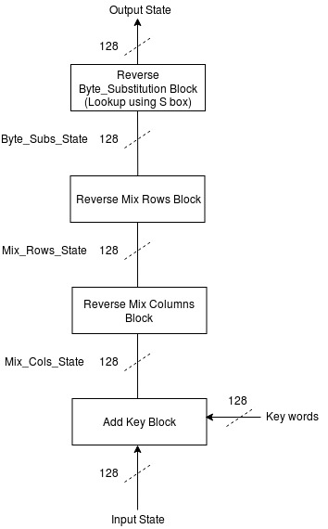

*Figure 23: AES Decryption Normal Inverse Stage Diagram*

**

*Figure 24: AES Decryption Normal Inverse Stage Waveform Example*

Figure 24 shows the process for calculating the inverse encryption round for AES. It would be somewhat accurate to state that the outputs of the encryption stages become the inputs and vice versa, but the process is slightly more involved.

To start, the Add Key block works exactly the same as before, however the key inputs are the reverse for encryption. The last key word for encryption is the first key word for decryption. This is due to the order of steps being the opposite as encryption.

The Reverse Mix Columns step works exactly the same as the encryption step, except for one difference. The standard matrix that was used prior for multiplication is replaced by its inverse matrix for the multiplication in decryption. This matrix is also defined in the AES standard, but the order of operations remains the same in calculation.

The Reverse Mix Rows step works in the opposite manner of the encryption step. To delve further, the 4th row is shifted bytewise to the right 3 times, the 3rd row twice, the 2nd row once, and the first row is left unmodified.

Finally, the byte substitution is done in reverse as well. This would essentially turn the lookup table used for encryption and reverse it, making its outputs its inputs and vice versa.

The order of these steps is reversed from the normal encryption, but other than their order and inversions in some stages, the order of evaluating the math is the same as encryption. Therefore, most of the in and out functionality is simply derived from the encryption section of AES.

|  |  |  |  |  |  |
| --- | --- | --- | --- | --- | --- |
| **Functional Block** | **RTL Diagram** | **Component Category** | **Size (${um^{2}}^{})$** | **Amount** | **Area (${um^{2}}^{})$** |
| Normal Stage | N/A | 1 bit 2-way Multiplexer (SBox) | 1000 | 2048 | 2048000 |
| Normal Stage | N/A | Gate (Add Key) | 500 | 128 | 64000 |
| Normal Stage | N/A | 1 bit 2-way Multiplexer (Mix Col) | 1000 | 512 | 512000 |
| Normal Stage | N/A | Gate (Mix Col) | 500 | 768 | 384000 |
| **Total Area w/ Wiring** ( ${um^{2})}^{}$ | | 4512000 | | | |

*Table 16: AES Decryption Normal Stage Area Budgeting*

**Actual Area: 4,679,154 um^2**

This area was slightly more than calculated. This was due to the addition of multiplexers to choose the key word used for the Key Addition step in the encryption module. These 13 128 bit wide multiplexers would add significant area usage without even the wiring delay.   
 This stage uses the same area calculations as the encryption normal stage. Add keys remains a 128 bitwise XOR operation, the Reverse Mix Rows is reverse bit concatenation, and the S-box inverse transformation remains the same size as the forward size transformation. The only notable difference is Reverse Mix Rows. Here, since the design varies based on the inverse matrix of encryption Mix Rows, it was assumed that twice the amount of multiplexers are used. This will cover for any vague area usage, as well as other functions covered in this section. Hence, our area for the multiplexers comes out to 2 X 2 X 8 X 16 X 1000 um squared.

**3.1.4.3 AES Decryption Special Inverse Stage**

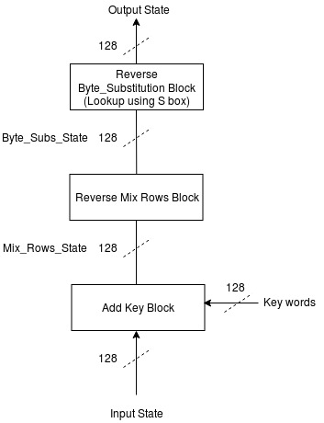

*Figure 25: AES Decryption Special Inverse Stage Diagram*

**

*Figure 26: AES Decryption Special Inverse Stage Diagram*

Here, just like the special encryption round, the special decryption round functions exactly the same as the normal round save for the Reverse Mix Columns step. This step is excluded from the first round of decryption. All other sub blocks and the general order of operation behave exactly the same as the normal inversion stage.

|  |  |  |  |  |  |
| --- | --- | --- | --- | --- | --- |
| **Functional Block** | **RTL Diagram** | **Component Category** | **Size (${um^{2}}^{})$** | **Amount** | **Area (${um^{2}}^{})$** |
| Special Inverse Stage | N/A | N/A | N/A | N/A | 0 |
| **Total Area w/ Wiring** ( ${um^{2})}^{}$ | | 0 | **Total Area w/ Wiring** ( ${mm^{2})}^{}$ | | 0 |

*Table 17: AES Decryption Special Stage Area Budgeting*

Just like encryption, The same hardware used for the normal decryption stage to perform the special decryption stage. Again, multiplexers are used to isolate the Reverse Mix Columns step from the normal decryption stage, which performs the same functionality as the special stage. This conserves a large amount of area while not compromising performance.

**3.1.4.4 AES Key Expansion Block**



*Figure 27: Functional diagram for Key Expansion*

In both the encryption and decryption algorithms, the Key Expansion block is used to produce independent keys for key addition at every round. Each word Wk is represented by 4 bytes, making each W 32 bits long. The first key addition is done with words W3…W0, and the second with W7...W4. To generate independency from the key, a transformation function is applied to the last word of the key (The most significant 4 bytes). This function includes a byte left rotation, a byte-by-byte substitution using the S-box, and a byte XOR with a round constant. This result is bitwise XOR’d with the matching position of the previous round. In this case, Trans(W7) + W0 = W8. Calculating the words for the same round is simply a bitwise XOR of the previous word and the word matching the position in the previous round. This continues until 8 words in total are generated. These words can carry through for 2 additions, and therefore 2 rounds. To generate 8 more words, the same process is iterated. This block also includes some external controls from the round counter, but overall only implements a few multiplexers and little combinational logic.

|  |  |  |  |  |  |
| --- | --- | --- | --- | --- | --- |
| **Functional Block** | **RTL Diagram** | **Component Category** | **Size (** | **Amount** | **Area (**  **No wiring** |
| Key Expansion | N/A | 1 bit 2-way Multiplexer (SBox) | 1000 | 512 | 512000 |
| Key Expansion | N/A | Gate (Add Key) | 500 | 288 | 144000 |
| **Total Area w/ Wiring** ( ${um^{2})}^{}$ | | 984000 | | | |

*Table 18: Key Expansion Area Calculation*

**Actual Area: 6,221,488.5 um^2**

This area was substantially larger than originally calculated, however there are reasons for this increase. For example, there was around 1.5 mm^2 approved for this segment of the design to have 13 128 bit flip flops with no reset to hold the keys generated by the key expansion process. In addition, another S-box transformation was needed, adding approximately 1 mm^2 to the design. Adding these with the estimates yields around 3.5 mm^2, and with wiring around 5.25 mm^2. This expansion was made larger by multiplexers to change how the keys are stored by the expansion. This would account for most of the large area usage in this design.

For the key expansion block, the XOR gates are used 8 times for the XOR operations between words, along with one extra time in the key expansion. This leads to 288 XOR gates used in the design. The SBox in the algorithm also is reduced to 1/4th size from the normal Sbox due to only operating on 32 bits of data instead of 128. The storing and iteration of the keys are handled in the top level design for the encryption module.

**3.1.5 USB Receiver Protocol Top Level**

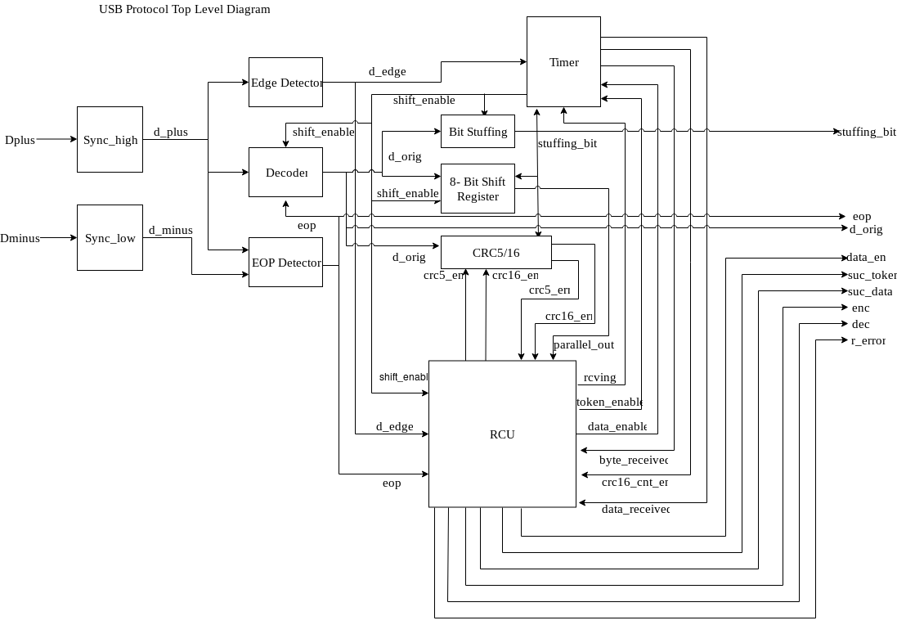

*Figure 28: USB Receiver Protocol Top Level Diagram*

Figure 28 shows the high level function block interactions for the USB protocol. The USB protocol first receives NRS-encoded data streams in the form of Dplus and its complement Dminus. Both Dplus and Dminus are run through synchronizers and then fed into various functional blocks. The Edge Detector block receives the d_plus synchronous signal as an input and outputs d_edge to the Timer, Decoder, and RCU blocks. The EOP Detector receives both the d_plus and the d_minus as inputs and outputs the eop signal to the Decoder and the RCU. The Decoder receives the eop signal, the d_plus, and the shift_enable signals and outputs the d_orig or decoded data to the Bit Stuffing and 8-Bit Shift Register blocks. The Timer block receives the d_egde signal and rcving, and outputs the byte_received, crc16_recieved, data_received, shift_enable to the RCU and just the shift_enable to the Bit Stuffing, 8-Bit Register, and Decoder. The Bit Stuffing block receives input shift_enable and d_orig, and outputs bit_enable to the 8-Bit Shift Register. The 8-Bit Shift Register receives input d_orig, bit_enable, and shift_enable, and sends the parallel output to the RCU for byte comparisons. The CRC5/16 block receives output d_orig from the decoder and outputs the crc error flags to the RCU. The RCU controls the state of the USB protocol and outputs various signals to the rest of the device.

|  |  |  |
| --- | --- | --- |
| **Module** | **Functional Block** | **Area** ( ${mm^{2}}^{})$ |
| USB Receiver Protocol | RCU | .15075 |
|  | Timer | .1386 |
|  | 64-bit StP Shift Register | .01995 |
|  | Bit Stuffing | .01485 |
|  | Decoder | .0063 |
|  | High/Low Synchronizers | .0096 |
|  | Edge Detector | .0055 |
|  | EOP Detector | .00075 |
|  | CRC5/CRC16 | .05415 |
| **Total Area no Wiring (sum of Modules / 1.5)** | | 0.26697 |
| **Total Area with Wiring Overhead** | | 0.40045 |

*Table 19: USB Receiver Protocol Total Area Budgeting*

**Actual Area: 405,027 um^2**

This area was almost identical to our estimates, only off by 5 um^2.

**3.1.5.1 USB RCU State Transition Diagram** 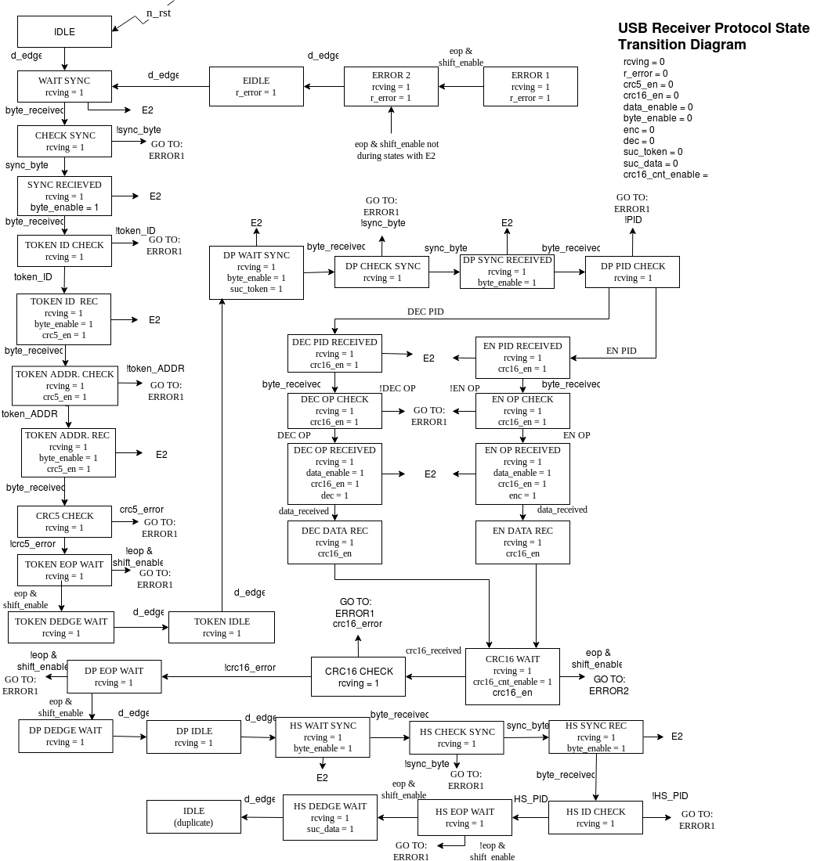

*Figure 29: USB RCU State Transition Diagram*

The RCU State Transition Diagram starts in the Idle state and sets all the state machine outputs to low before the device begins receiving that serially streamed data through the Dplus and Dminus signals. At the first sign data is being transmitted (a raised d_edge signal) the state machine begins to work its way through all three packets of a USB 1.1 reception. With each packet a sync byte must be received first and an end of packet signal must designate the ending of the current packet. If a sync byte is received incorrectly, an eop signal is too early, or too late it signifies that there was an error in the reception and the RCU enters an error state and awaits the correct order of signals to signify the beginning of a new reception.

The first packet is the token packet and after the sync byte has been correctly received, a token packet ID byte must be received - like the rest of the PIDs, there are multiple versions depending on what the specific packets role to signal is, but our device only receives incoming transmissions of data so we only have one valid token PID (**2.3.2**) **-** if an incorrect PID is received, the device goes to an error state and the rest of the reception is ignored until signals show an new reception is beginning. If correct, the token address and endpoints are checked as well - again there should only be one valid result due to our standards defined in **section 2** - and if either is incorrect it enters and error state. If the token packet is all correct up to this point a CRC5 check is run to make sure the data has not been invalidated during the reception. Once, the CRC5 check is passed and eop signal must be sent followed by two edge flags to begin receiving the Data Packet.

Similar to the token packet, the first byte received should be the sync byte. If so, the second byte will be the data packet ID. We define two successful data packet IDs (one for encryption and one for encryption - **2.3.2**) and if either is received the next byte is checked to ensure that the operational ID (either encryption or decryption) matches the previous PID. If successful, the data reception begins and lasts for 128 bits (plus a delay period for the CRC16) and a CRC16 check is run. If the CRC16 check is correct the device must receive and eop signal followed by d_edges signalling the beginning of the handshake packet.

Again, the first byte of the handshake packet is the sync byte and the second byte should be the handshake packet ID - again there are many different standard IDs signaling different receptions or transmissions, but since our device is reception only we again only have one successful PID (the ACK) which signals an acknowledged reception. Following this ID and eop signal must be received and with that a full successful transmission has been received signaling to the rest of the device using the successful data flag before returning to the Idle state.

|  |  |  |  |  |  |
| --- | --- | --- | --- | --- | --- |
| **Functional Block** | **RTL Diagram** | **Component Category** | **Size (${um^{2}}^{})$** | **Amount** | **Area (${um^{2}}^{})$** |
| RCU | Finite State Machine | Flip Flops with Reset | 1600 | 5 | 8000 |
|  |  | 1 bit 2-way Multiplexer | 1500 | 45 | 67500 |
|  |  | Gate | 500 | 50 | 25000 |
| **Total Area w/ Wiring** ( ${um^{2})}^{}$ | | 150,750 | **Total Area w/ Wiring** ( ${mm^{2})}^{}$ | | .15075 |

*Table 20: Timer Area Budgeting*

**Actual Area: 122,121 um^2**

This area was slightly less than the calculated area. This could be due to conservative estimates used in the estimations for gate and flip flop area.

Table 20 shows the calculation used to determine the area requirements of the RCU. As this is a finite state machine it is already an RTL and therefore does not have an sub calculations. It is assumed that a flip flop with a reset is 1600 micrometers, a gate is 500 micrometers, and a 1 bit 2-way multiplexer is made of approximately 3 gates (this size is not lowered for simplification as there are not many multiplexers being used in cooperation).The gates are estimated from comparison signals for the multiplexers and various comparators for the PIDS, the multiplexers are used for the selections between each state and the flip flops are used to keep track of what state the machine is located.

**3.1.5.2 Timer**

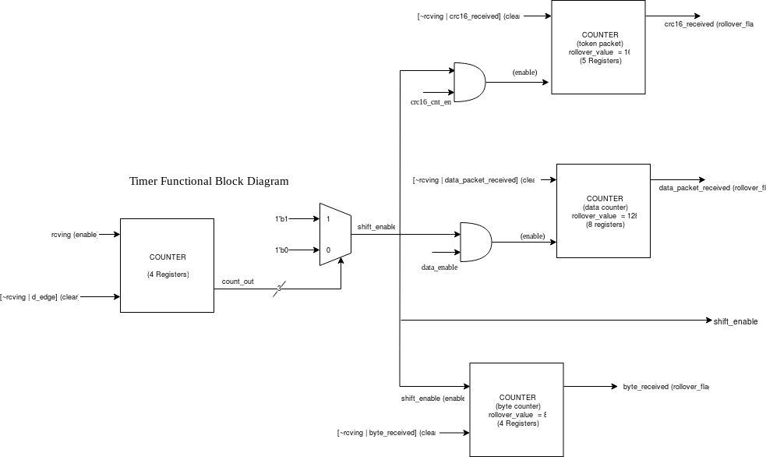

*Figure 30: USB Receiver Protocol Timer Diagram*

*Figure 31: USB Receiver Protocol Timer Waveform Examples*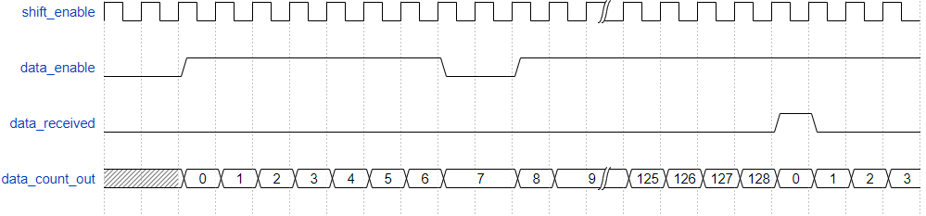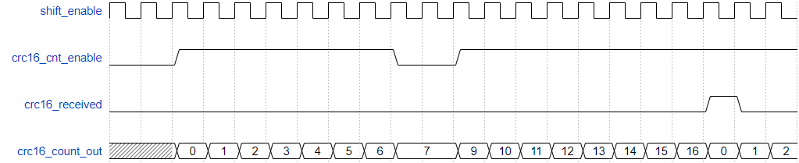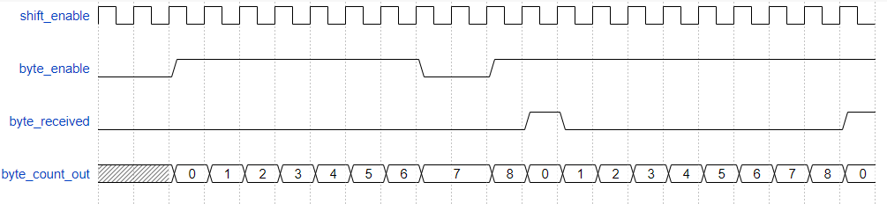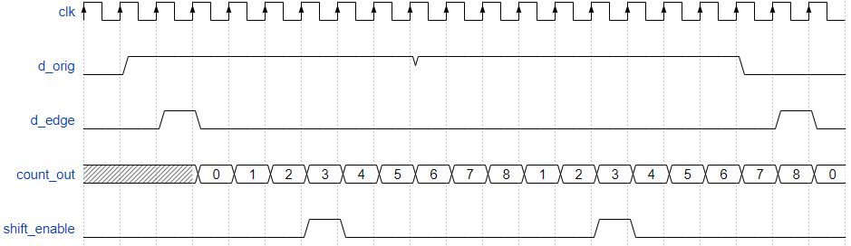

The USB timer functionality is divided into four counters. One for the instantiation of the shift enable (which in turn used in combination with other signals as an enable for the other counters), one to count up to when a byte has been shifted in, one to count up to the 128 bits of a data packet, and one to count the 16 bits of the CRC16 packet. Each is designed using a flex counter use various signals to clear (reset) the counter as well as a flag that is raised once the desired value is reached. The shift enable counter is special as it does not raise the shift enable when it reaches its rollover value, but instead uses a mux and a comparator to raise the signal once it reaches a specified count value (in this case, 3 is uses as it tends to place the shift enable towards the beginning half or each bit transmission allowing for safe reception). The waveforms above show that the counter iterates only when both the shift enable and the counters respective enable signal is raised and resets back once a rollover value is reached (as in the case of the data counter, the data received is the flag that signals the rollover value has been reached).

**3.1.5.2.1 Timer - Flex Counter RTL**



*Figure 32: Flex Counter RTL*

The Flexible Counter is used as a means of counting up to various values based on the number of registers used to store the count value. The combinational logic is split into two sections; one uses a series of selections to determine how the count will be updated and the other to determine how the rollover flag will be updated. For the flexible counter, other than the asynchronous reset, the clear holds the priority for updating the current count. If the clear is high, the count is synchronously reset to zero. The rollover flag holds the next high priority and if it is high while the clear is low and the count enable is high the count is set back to one. If neither the clear or the rollover flag is high and the count enable is high the count is raised by one. If the next count is every equal to the rollover value, the rollover flag register is raised, which in turn will raise the rollover flag with the next clock cycle. The rollover flag and the count out are stored in separate registers that asynchronous reset to zero when the reset is low.

|  |  |  |  |  |  |
| --- | --- | --- | --- | --- | --- |
| **Functional Block** | **RTL Diagram** | **Component Category** | **Size (${um^{2}}^{})$** | **Amount** | **Area (${um^{2}}^{})$** |
| Timer | Flex Counter | Gate | 500 | 5 | 2500 |
|  | | 1 bit 2-way Multiplexer | 1500 | 5 | 7500 |
| Flip Flop with Reset | 1600 | 4 - 8 | 6400 - 9600 |
|  | | | | | |
|  | N/A | Gate | 500 | 18 | 9000 |
|  |  | 1 bit 2-way Multiplexer | 1500 | 1 | 1500 |
| **Total Area w/ Wiring** ( ${um^{2})}^{}$ | | 138,600 | **Total Area w/ Wiring** ( ${mm^{2})}^{}$ | | .1386 |

*Table 21: Timer Area Budgeting*

**Actual Area: 130,086 um^2**

This area was almost identical to the estimated area in our calculations.

In Table 21, the area budgeting for the Timer functional block is calculated. For this calculation, it was assumed that the average gate equivalent was 500 micrometers squared, that an inverter is roughly half the area of an average gate, a 1 bit 2-way multiplexer is composed of roughly three gates (and is not being simplified enough to lower the total area as there are a low number of multiplexers being used even though they have constants being fed to some of the inputs), and that a flip flop with a reset has an area of 1600 micrometers squared. The Timer block is made of two components: the flexible counters and the small bits of combination logic between the counters (N/A). The small bit of combinational logic in between the flex counters is just a few AND/OR gates for specific inputs of the flexible counters, a 3 bit comparator for the input of the shift enable multiplexer, and the said multiplexer. There are four flex counters in the timer that range in size from 4 - 6 registers (dependent on what they count up to). There are two 4 bit, one 5 bit, and one 8 bit flex counters used for the timer. All these components are summed and multiplied by 1.5 for the wiring overhead to determine the total approximate area of the Timer functional block.

**3.1.5.3 8-Bit Serial to Parallel Shift Register**

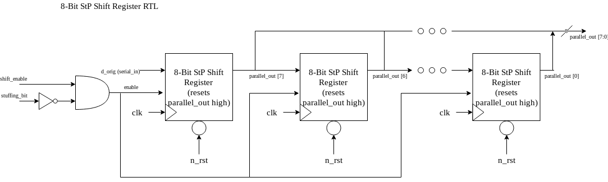

*Figure 33: USB Receiver Protocol 8-Bit Serial to Parallel Shift Register Diagram*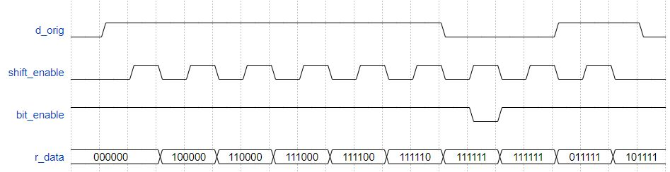

*Figure 34: USB Receiver Protocol 8-Bit Serial to Parallel Shift Register Waveform Example*

The waveform above is modified to have an r_data of 6 bits down from the actual 8 bits to make showing the functionality simpler. The 8-Bit Serial to Parallel Shift Register will store up to one byte (8 bits) of incoming values and hold these values so they can be used to check at that the correct byte has been received for PIDs, operational bytes, and sync bytes. The data is shifted in least significant bit first as USB 1.1 standard defines. The 8-Bit Data Shift Register has a dual component enable – the shift register only shifts when both the stuffing bit flag is low and shift enable signal is high. This allows our data to ignore any stuffed bits and continue to only receive non-stuffed data bits.

|  |  |  |  |  |  |
| --- | --- | --- | --- | --- | --- |
| **Functional Block** | **RTL Diagram** | **Component Category** | **Size (${um^{2}}^{})$** | **Amount** | **Area (${um^{2}}^{})$** |
| 8-bit StP Shift Register | N/A | Gate | 500 | 1 | 500 |
|  |  | Flip Flop with Reset | 1600 | 8 | 12,800 |
| **Total Area w/ Wiring** ( ${um^{2})}^{}$ | | 19,950 | **Total Area w/ Wiring** ( ${mm^{2})}^{}$ | | .01995 |

*Table 22: 8-bit StP Shift Register Area Budgeting*

**Actual Area: 26,109 um^2**

This area is slightly larger than the estimated calculation, however given the magnitude of area, the difference does not amount to much.

Table 22 shows the calculations used to determine the approximate area for the 8-bit StP Shift Register functional block. Since this block is just a shift register, there is no RTL subgroups to calculate individually, but instead the block is just calculated as a whole. It is assumed that a flip flop with reset is 1600 micrometers squared and that the average gate is 500 micrometers squared. The design consists of 64 flip flops in row with an AND gate used to control the shift enable signal.

**3.1.5.4 Bit Stuffing**

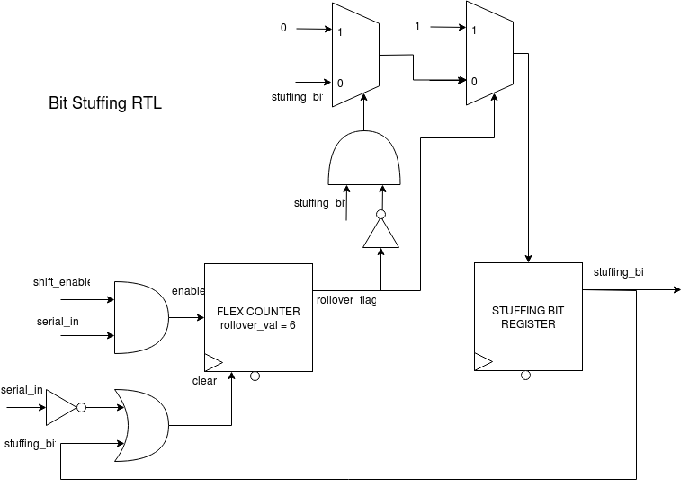

*Figure 35: USB Receiver Protocol Bit Stuffing Block Diagram*

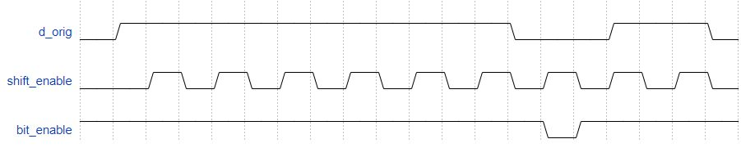

*Figure 36: USB Receiver Protocol Bit Stuffing Block Waveform Example*

The bit stuffing block functions in correlation to how it is explained in section 2.3.5. To register the stuffing bit, a counter is used that, when the count reaches a rollover value of six (the number of ones needed to trigger a stuffing bit) a flag is raised and stored for one bit cycle or until the ignored stuffing bit is passed. To do this, the counter uses the serial in data from the d_orig along with the shift enable signal as the enable and the inverse serial in data and the stuffing bit as the clear as this will increment the count with every 1-bit shifted in and lower if a zero is ever registered or with the rollover flag if six 1-bits in succession are shifted in .

|  |  |  |  |  |  |
| --- | --- | --- | --- | --- | --- |
| **Functional Block** | **RTL Diagram** | **Component Category** | **Size (${um^{2}}^{})$** | **Amount** | **Area (${um^{2}}^{})$** |
| Bit Stuffing | N/A | Gate | 500 | 4 | 2000 |
|  |  | Flip Flop with Reset | 1600 | 4 | 6400 |
|  |  | 1 bit 2-way Multiplexer | 1500 | 2 | 1500 |
| **Total Area w/ Wiring** ( ${um^{2})}^{}$ | | 14,850 | **Total Area w/ Wiring** ( ${mm^{2})}^{}$ | | .01485 |

*Table 23: Bit Stuffing Area Budgeting*

**Actual Area: 25,704 um^2**

This area is slightly larger than the estimated area. However, the area is not significantly larger in terms of magnitude in the design. This could be due to slightly revised parts in the design to make the bit stuffing operate more efficiently, like changing the model to a flex counter model instead.

Table 23 shows the calculations used to determine the area requirements for the bit stuffing functional block. Because the functional block for bit stuffing itself is already an RTL it does not have have any RTL subcomponents in calculation. It is assumed that a flip flop with reset is 1600 micrometers squared, the gate equivalent is 500 micrometers squared, and that a multiplexer is made of approximately 3 gates (as there is only one there it will likely not be simplified very much). The bit stuffing block incorporates a 3-bit flex counter and control signals for the enable along with a register to store the stuffing bit for a bit cycle.

**3.1.5.5 Decoder**

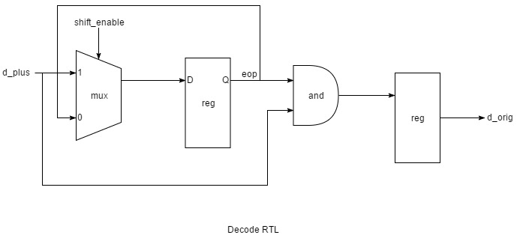

*Figure 37: USB Receiver Protocol Decoder Diagram*

*Figure 38: USB Receiver Protocol Decoder Waveform Example*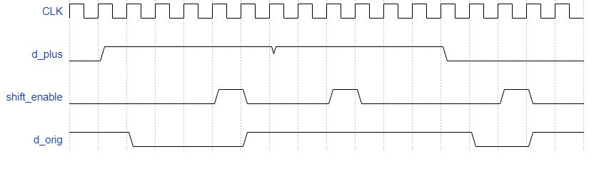

The decoder block’s purpose is to decode the NRZ-encoded data stream from the synchronized input. The decoder functions by comparing a registered d_plus value and a stored bit through and XNOR logic gate. The value of the stored bit is determined through a series of selections by multiplexers using the shift_enable and eop signals. The decoded output (d_orig) is then sent to the Bit Stuffing block and the 64-Bit Serial to Parallel Shift Register.

|  |  |  |  |  |  |
| --- | --- | --- | --- | --- | --- |
| **Functional Block** | **RTL Diagram** | **Component Category** | **Size (${um^{2}}^{})$** | **Amount** | **Area (${um^{2}}^{})$** |
| Decoder | N/A | Gate | 500 | 1 | 500 |
|  |  | Flip Flop with Reset | 1600 | 2 | 3200 |
|  |  | 1 bit 2-way Multiplexer | 1500 | 1 | 1500 |
| **Total Area w/ Wiring** ( ${um^{2})}^{}$ | | 6,300 | **Total Area w/ Wiring** ( ${mm^{2})}^{}$ | | .0063 |

*Table 24: Decoder Area Budgeting*

**Actual Area: 6,345 um^2**

This design was almost exactly the same area as estimated.

Table 24 shows the calculations used to determine the area requirements for the Decoder functional block. This block is very simple and already at an RTL so there is no sublevel calculations shown. It is assumed that a flip flop with reset is 1600 micrometers squared, the gate equivalent is 500 micrometers squared, and that a multiplexer is made of approximately 3 gates (as there is only one there it will likely not be simplified very much). The design is made of 1 multiplexer, two registers and an AND gate.

**3.1.5.6 Synchronizers**

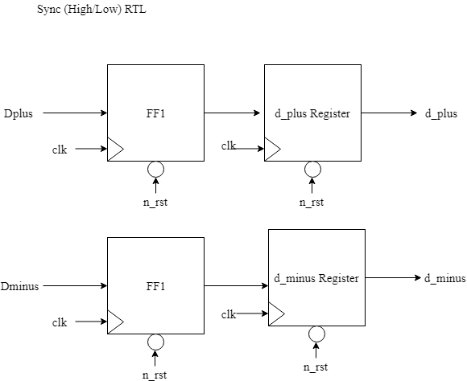

*Figure 39: USB Receiver Protocol Synchronizer (High and Low) Diagrams*

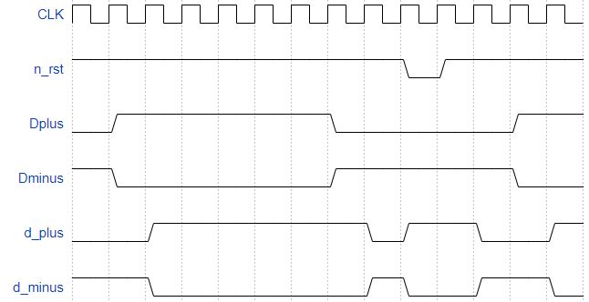

*Figure 40: USB Receiver Protocol Synchronizer Waveform Example*

The USB protocol synchronizes the input NRZ-encoded data stream through a high synchronizer for Dplus and a low synchronizer for Dminus. This is done to ensure stability with the data flow to the rest of the device. The difference between these two synchronizers is their behavior when asynchronously reset; the high sync will reset the output to high and the low synch will reset the output to low. This synchronized input is then sent to the Edge Detector (d_plus), Decoder (d_plus), and EOP Detector (d_plus / d_minus).

|  |  |  |  |  |  |
| --- | --- | --- | --- | --- | --- |
| **Functional Block** | **RTL Diagram** | **Component Category** | **Size (${um^{2}}^{})$** | **Amount** | **Area (${um^{2}}^{})$** |
| Synchronizers | N/A | Flip Flop with Reset | 1600 | 4 | 6400 |
| **Total Area w/ Wiring** ( ${um^{2})}^{}$ | | 9,600 | **Total Area w/ Wiring** ( ${mm^{2})}^{}$ | | .0096 |

*Table 25: Synchronizers Area Budgeting*

**Actual Area: 9,504 um^2**

This area is almost identical to the calculated area for this component.

Table 25 shows the calculations used to determine that area required for the synchronizers. The synchronizers are already at an RTL level as a functional block and therefore do not have sublevel calculations. It is assumed that a flip flop with reset is 1600 micrometers squared. Each sync is made of two flip flop, so a total of four are used for the high and low synchronizers.

**3.1.5.7 Edge Detector**

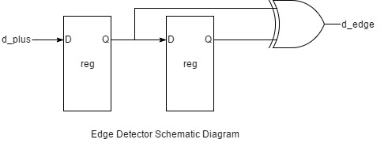

*Figure 41: USB Receiver Protocol Edge Detector Diagram*

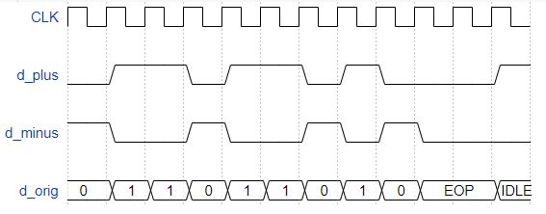

*Figure 42: USB Receiver Protocol Edge Detector Waveform Example*

The edge detector tracks when there has been a transition in the synchronized data stream input, d_plus, from low to high or high to low. This is accomplished by comparing the a registered d_plus value and the previously registered d_plus value comparing them through a logic XOR gate. The edge detection output (d_edge) is then sent to the RCU and the Timer.

|  |  |  |  |  |  |
| --- | --- | --- | --- | --- | --- |
| **Functional Block** | **RTL Diagram** | **Component Category** | **Size (${um^{2}}^{})$** | **Amount** | **Area (${um^{2}}^{})$** |
| Edge Detector | N/A | Flip Flop with Reset | 1600 | 2 | 3200 |
|  |  | Gate | 500 | 1 | 500 |
| **Total Area w/ Wiring** ( ${um^{2})}^{}$ | | 5,550 | **Total Area w/ Wiring** ( ${mm^{2})}^{}$ | | .0055 |

*Table 26: Edge Detector Area Budgeting*

**Actual Area: 5,508 um^2**

This area is nearly identical to the estimated area for the edge detect block.

Table 26, shows the calculation used to determine the area required for the edge detector functional block. Since the functional blocks are already at a RTL level, there are no subcalulations. It is assumed that a flip flop with reset is 1600 micrometers squared and that an average gate is 500 micrometers squared. The edge detector is made of two flip flops and one XOR gate.

**3.1.5.8 EOP Detector**

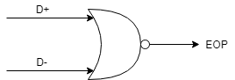

*Figure 43: USB Receiver Protocol EOP Detector Functional Diagram*

The EOP Detector is used to track when an end of packet signal has been received through the D+/D-. This is found by using and NOR gate of the synchronized values of the D+/D-. The output eop signal is sent to the decoder and the RCU.

|  |  |  |  |  |  |
| --- | --- | --- | --- | --- | --- |
| **Functional Block** | **RTL Diagram** | **Component Category** | **Size (${um^{2}}^{})$** | **Amount** | **Area (${um^{2}}^{})$** |
| EOP Detector | N/A | Gate | 500 | 1 | 500 |
| **Total Area w/ Wiring** ( ${um^{2})}^{}$ | | 750 | **Total Area w/ Wiring** ( ${mm^{2})}^{}$ | | .00075 |

*Table 27: EOP Detector Area Budgeting*

**Actual Area: 324 um^2**

This area is almost identical to the area calculated for this design.

Table 27 is used to calculate the area requirement for the EOP Detector functional block. The EOP block is just a single gate and as such there is no sub calculation used for the area. It is assumed that an average gate is 500 micrometers. The design is made from just one gate.

**3.1.5.9 CRC Functional Block Diagram**

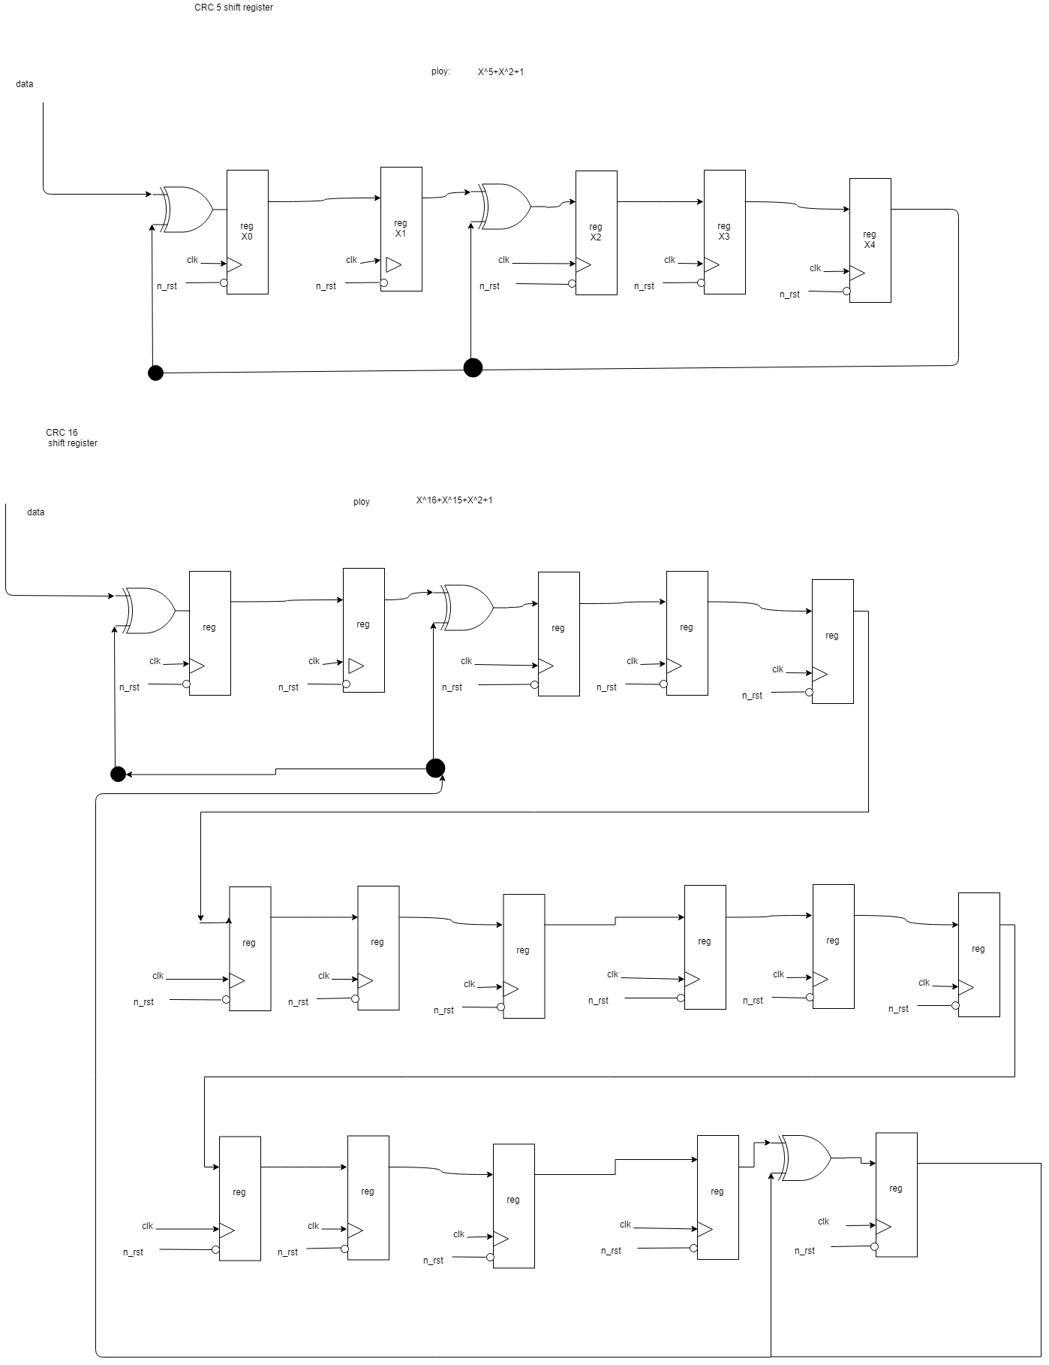

*Figure 44: USB Receiver Protocol CRC5 and CRC16 Internal Block Diagram*

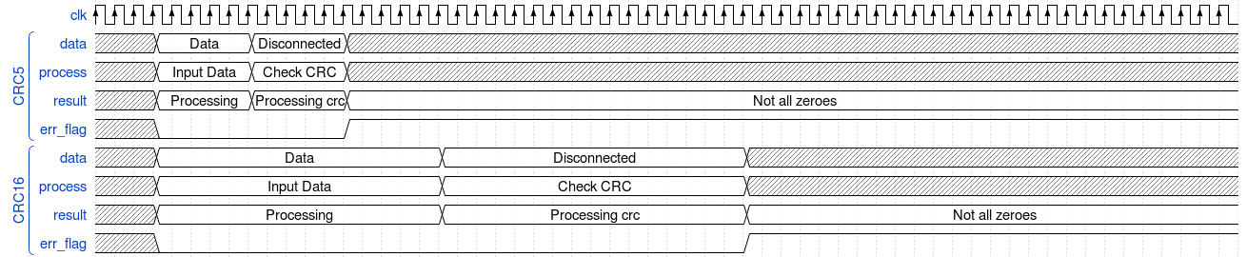

*Figure 45: USB Receiver Protocol CRC5 and CRC16 Waveform Example*

The description of how CRC works functionally can be found in **section 2.3.3**. The CRC block is used to check the validation of the token and data packets. If a packet is determined to be successfully transfered and passes the CRC check, the completion flag is raised and sent to the RCU. If an error appears when checking, an error flag is raised and sent the RCU.

|  |  |  |  |  |  |
| --- | --- | --- | --- | --- | --- |
| **Functional Block** | **RTL Diagram** | **Component Category** | **Size (${um^{2}}^{})$** | **Amount** | **Area (${um^{2}}^{})$** |
| CRC5/16 | CRC 5 | Flip Flop with Reset | 1600 | 5 | 8000 |
|  |  | Gate | 500 | 2 | 1000 |
|  |  |  |  |  |  |
|  | CRC 16 | Flip Flop with Reset | 1600 | 16 | 25600 |
|  |  | Gate | 500 | 3 | 1500 |
|  |  |  |  |  |  |
| **Total Area w/ Wiring** ( ${um^{2})}^{}$ | | 54,150 | **Total Area w/ Wiring** ( ${mm^{2})}^{}$ | | .05415 |

*Table 28: CRC5/16 Area Budgeting*

**Actual Area: 79,218 um^2**

This area is slightly larger than the estimated area. This could be due to the addition of start signals for the CRC module. This was used to control the validity of the serial data feeding in to this module, as well as when it was appropriate to check the error flag. This change created a few more multiplexers.

Tabel 28 shows the calculation for the area requirement of the CRC Functional block. This block contains two RTLs; one for the CRC5 and another for the CRC16. It is assumed that a flip flop with a reset is 1600 micrometers squared and that an average gate is 500 micrometers squared. The RTL show gate level the components of each of the CRCs and were used to determine the how we calculated the area requirement.

**3.2 Design Timing Analysis**

The 5 most critical paths in the design are well underneath our target clock period. Their calculations are broken up underneath **Table 29**, as well as the rationale behind each calculation.

|  |  |  |  |  |  |  |  |
| --- | --- | --- | --- | --- | --- | --- | --- |
| **Starting Component** | **Propagation Delay (ns)** | **Combinational Logic** | **Propagation Delay (ns)** | **Ending Component** | **Setup Time or Propagation Delay (ns)** | **Total Path Delay (ns)** | **Target Clock Period (ns)** |
| Input Encrypt Data | 0.4 | AES Encryption Round | 3.6 | Current State Register (Enc) | 0.2 | 5.0 | 10.416 |
| Input Decrypt Data | 0.4 | AES Decryption Round | 4.0 | Current State Register (Dec) | 0.2 | 5.5 | 10.416 |
| Round Key Register (Enc) | 0.4 | New Word Calculation | 2.7 | Round Key Register (Enc) | 0.2 | 4.0 | 10.416 |
| Round Key Register (Dec) | 0.4 | New Word Calculation | 2.7 | Round Key Register (Dec) | 0.2 | 4.0 | 10.416 |
| Current State Register (Dec) | 0.4 | AES Special Decryption Round | 1.7 | Current State Register (Dec) | 0.2 | 2.8 | 10.416 |

*Table 29: 5 Largest Critical Paths Timing Analysis*

**3.2.1 AES Encryption Round**

The input data comes from a register = 0.4 ns for propagation delay. It then enters an Add Key stage, which involves a bitwise XOR gate = 0.2 ns. Then it proceeds through a normal round of encryption. It goes through Byte Substitution, which is assumed to be large gate representations of multiplexers. To assume for reasonable delay, along with mapped simulations to prove it is reasonable, the input data is presumed to go through 5 large gate delays of 0.3 ns each = 1.5 ns. Then it enters the Mix Columns stage, which at worst involves an XOR gate through a large gate (multiplexer) and into 6 serial XOR gates = 0.2 + 0.3 + 0.2 X 6 = 1.7 ns. It enters another Add Key stage = 0.2 ns. This data is then clocked into the current state register for the next round, which needs a setup time of 0.2 ns. Therefore, in total:

(0.4 + 0.2 + 1.5 + 1.7 + 0.2 + 0.2) X 1.2 (Wiring overhead delay) = **5.04 ns**

**3.2.2 AES Decryption Round**

The input data comes from a register = 0.4 ns for propagation delay. It proceeds through a normal round of decryption. It goes through Reverse Byte Substitution, which is assumed to be large gate representations of multiplexers. To assume for reasonable delay, along with mapped simulations to prove it is reasonable, the input data is presumed to go through 5 large gate delays of 0.3 ns each = 1.5 ns. Then it enters the Reverse Mix Columns stage, which at worst involves an XOR gate through three large gates (multiplexers) (Reverse Mix Columns is larger/longer due to larger polynomial coefficients) and into 6 serial XOR gates = 0.2 + 0.3 X 3 + 0.2 X 6 = 2.3 ns. It enters another Add Key stage = 0.2 ns. This data is then clocked into the current state register for the next round, which needs a setup time of 0.2 ns. Therefore, in total:

(0.4 + 1.5 + 2.3 + 0.2 + 0.2) X 1.2 (Wiring overhead delay) = **5.52 ns**

**3.2.3 New Word Calculation (Encryption)**

The input data comes from a register = 0.4 ns for propagation delay. It enters the transformation function to generate 8 new keywords. This involves byte rotate left (no op), a partial byte substitution using the S-box (Since it only operates on 4 bytes, it is assumed to be ⅗ of the normal S-box, giving a delay of 1.5 ns X ⅗ = 0.9 ns), XOR’d with a round constant (0.2ns), then ran through 8 consecutive XOR gates to generate the next 8 words. It is then clocked to be used for the next word setup to generate the new words, requiring a setup time of 0.2 ns.

(0.4 + 0.9 + 0.2 X 9 + 0.2) X 1.2 (Wiring overhead delay) = **3.96 ns**

**3.2.4 New Word Calculation (Decryption)**

This calculation is the same as the new word calculation for Encryption, however it is present twice in the chip design. Therefore, it has the same delay of **3.96 ns**. The calculations are done exactly the same, and omitted to avoid repetition.

**3.2.5 AES Special Decryption Round**

This calculation is the same as the AES normal decryption round, save for the removal of the 2.3 ns time for the Mix Columns stage. This removal also makes it the same as the AES Special Encryption round. For the process:

The input data comes from a register = 0.4 ns for propagation delay. Then it proceeds through a normal round of decryption. It goes through Reverse Byte Substitution, which is assumed to be large gate representations of multiplexers. To assume for reasonable delay, along with mapped simulations to prove it is reasonable, the input data is presumed to go through 5 large gate delays of 0.3 ns each = 1.5 ns. It enters an Add Key stage = 0.2 ns. This data is then clocked into the current state register for the next round, which needs a setup time of 0.2 ns. Therefore, in total:

(0.4 + 1.5 + 0.2 + 0.2) X 1.2 (Wiring overhead delay) = **2.76 ns**

*Figure 46: 1st Most Critical Path from Placing and Routing*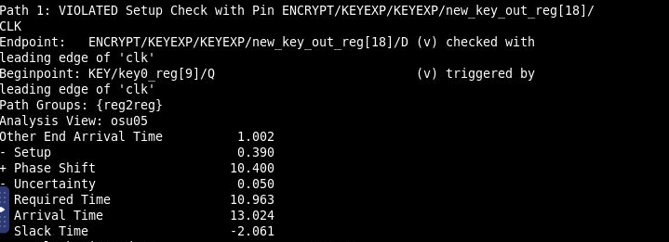

The longest path involved the key expansion combinational logic of using the same key to generate the next key. This is indicated by the new_key_out_reg input being the endpoint of the critical path. This path could surely be the longest, given that at the time of calculating the delays in our design, there was only one s-box taken into account. However, two ended up being needed for the key expansion, which adds significant path to the design.

*Figure 47: 2nd Most Critical Path from Placing and Routing*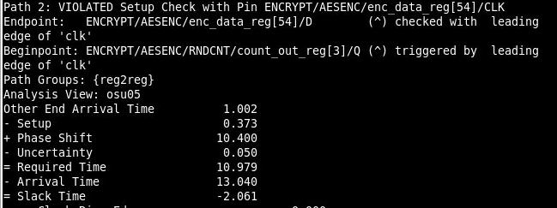

This path relates to the round count being used for the AES encryption to decide the key being used for the Key Addition Stage. Given that this travels through an entire AES Stage of encryption and leads to the input of the state register, it’s easy to see this path being one of the longer ones in the design.

*Figure 48: 3rd Most Critical Path from Placing and Routing*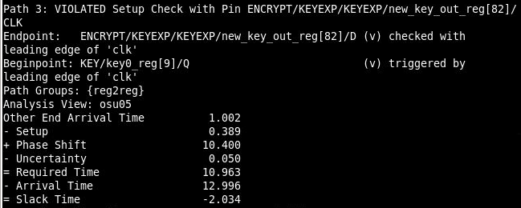

This path is almost exactly the same as the first one, just with different bit indices of the same overall registers. It only made the list due to being slightly smaller in delay.

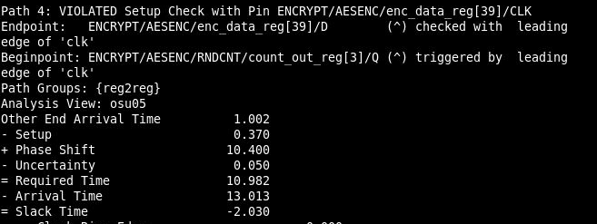

*Figure 49: 4th Most Critical Path from Placing and Routing*

This path is almost identical to the second largest critical path, given that the data path begins and ends on the same signals in different bit indices. Again, it only makes this list due to being slightly smaller in delay time.

*Figure 50: 5th Most Critical Path from Placing and Routing*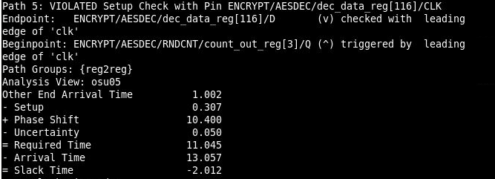

This path is the same as the 4th and 2nd largest paths, however this path is present in the decryptor and NOT the encryptor. The delay times are mostly comparable to the encryption, however this path actually belongs to the decryption module. This path is understandable given that the combinational logic in the decryption module is slightly longer than that in the encryption module.

As for comparison to the estimated critical paths, our estimations were somewhat accurate in determining which paths would be the most critical. Immediately, it was evident that key expansion, AES encryption and decryption would be the longest paths of combinational logic in our design, especially compared to the complexity of the other protocols. However, the estimates were different than the order generated by the Innovus timing report.

For example, it was clear that the AES Decryption would take longer than the encryption, due to having the exact same type of logic save for a more complex mix_columns stage. However, the paths ended up being nearly identical in delay with Encryption slightly being worse. This could be due to the compiler recognizing this longer path and distributing resources with a focus on minimizing decryption to balance the impartial delays in this design. This in turn increased the delay in Encryption until they were approximately the same.

Also, the Key Expansion block ended up coming out on top in terms of delay. At the time, it would have been shocking, however there were missing resources that were not accounted for in the initial path delays. The Key Expansion for AES 256 actually requires 2 forward s-box transformations, however only one was used in the preliminary calculations for delay. This part of all AES combinational logic by far adds the most delay to a design, and it would easily put it at the longest path if it were accounted for from the beginning of calculations.

In summary, the estimates made indicated that AES Decryption would be the longest, followed by AES Encryption and the Key Expansion. However, the Key Expansion ended up being the worst due to longer path delays by last minute added resources, followed by a close tie between the two AES stages. This was due to resources distributed to even out the delay between these two otherwise incomparable paths of logic. Another reason that would greatly contribute to delay and cause the violations in the paths would be the pinout placement in the layout generation. Given the area of our design and the location of the resources used to realize this logic, the wiring delay adds significant slack onto all paths in this already complex design.

**4. Success Criteria**

A successful design will meet the following criteria to verify successful operation:

**4.1 Fixed Criteria**

1. (2 points) Test benches for each top level block in the design and the top level design. These test benches exhibit full functionality and can be used to demonstrate the functional requirements given in the design specific success criteria.

This criteria has been completed and the following files can be found for reference in the final project submission:

(Root directory: mg92/Final_Project_Submission)

/source/tb_usb_top.sv (USB & CRC Top Level Test bench)

/source/tb_AES_Enc_Dec_top.sv (AES Encryption and Decryption Top Level Test Bench)

/source/tb_APB_Protocol.sv (APB Top Level Test bench)

/source/tb_data_register.sv (Test bench for top level data register)

/source/tb_key_register.sv (Test bench for top level key register)

/source/tb_mcu.sv (Test bench for MCU)

/source/tb_Final_Project_top.sv (Entire Module Test bench)

2. (4 points) Entire design synthesizes completely, without any inferred latches, timing arcs, and, sensitivity list warnings.

This criteria has been completed. The following report can be examined for warnings in the synthesis of our top level test bench:

/reports/Final_Project_top.rep

3. (2 points) The source and mapped versions of each block and the top level design behave the same for all test cases. There are only timing errors in the mapped version at t = 0.

This criteria has been completed. All of the following waveforms used to demonstrate the functionality of the design are simulated in the mapped version. In addition, all of the mapped test benches for top level designs behave correctly.

4. (2 points) A complete IC layout is produced that passes all geometry and connectivity checks.

This criteria has been completed. The innovus report for the layout generation can be found at: reports/innovus.logv2 (screenshots of summaries for geometry and connectivity posted below)

A screenshot of the layout generated is shown here:

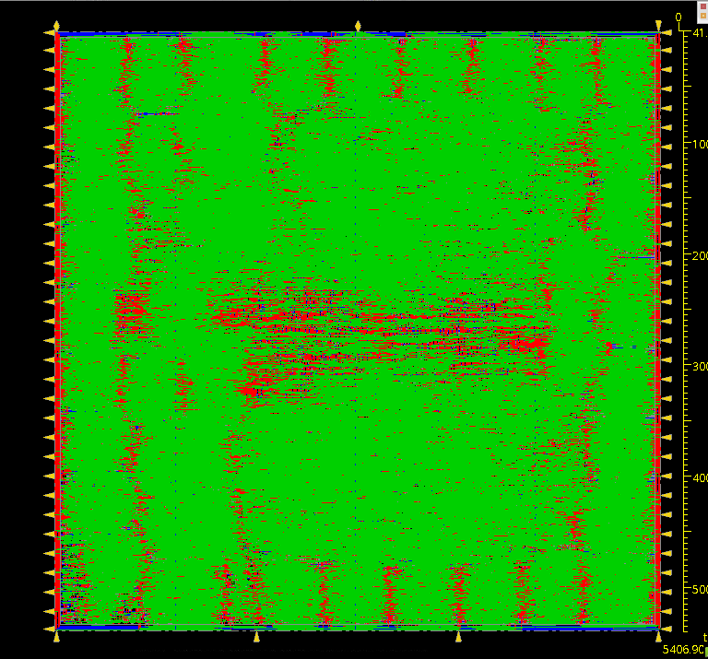

*Figure 51: Innovus Layout*

Geometry and Connectivity check result summaries are shown below in screenshots:

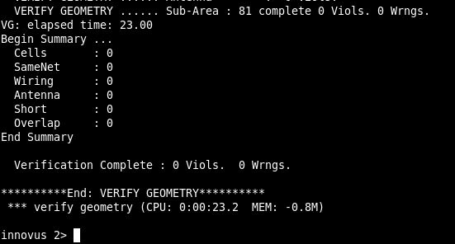

*Figure 52: Geometry Verification*

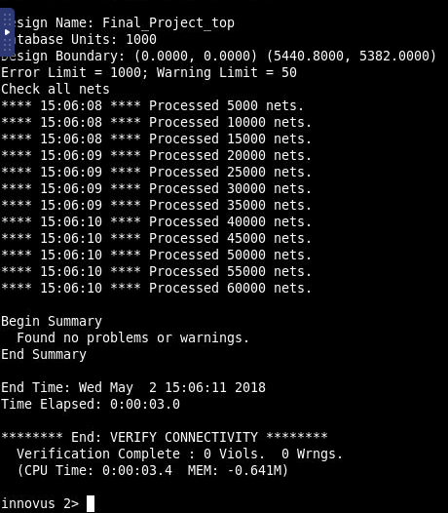

*Figure 53: Geometry Loop Connectivity*

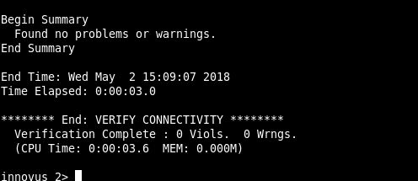

*Figure 54: Other Connectivity Verification*

5. (2 points) The entire design complies with targets for area, pin count, throughput, and clock rate. Partial credit in this criteria will be given if the targets are not met but are close enough to the target goals.

This target is partially completed. Our area is within 50% of the target area of 27 mm^2, being at 5.440 x 5.382 mm. Our target throughput for the design was well within the speed of the USB at 12 Mb/s. This speed can be seen in the following waveform:

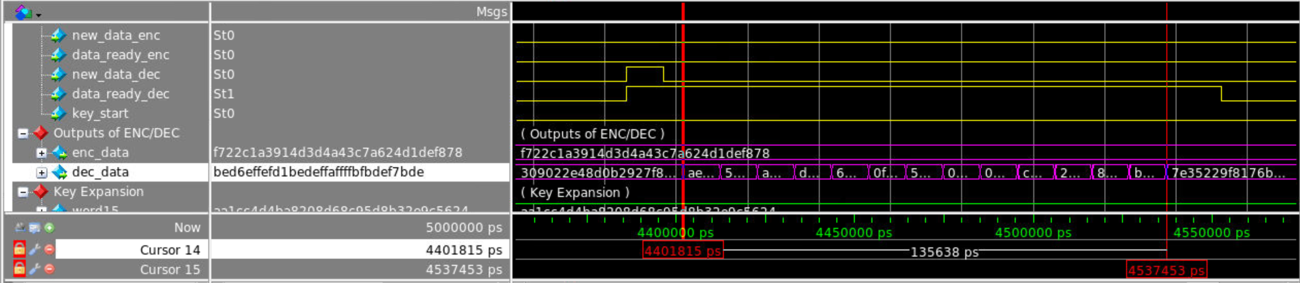

*Figure 55: Throughput Verification*

Here, the mapped design yields slightly higher throughput compared to the calculations made above. Therefore, the design operates at a much higher speed than the USB.

The final pin count was 71 (See **Figure 51** for pins). The design had 2 less pins, however this was due to the project becoming an SOC project. Therefore, the pins for VDD and ground were already included in the different layers of the innovus design and therefore removed.

The design’s system clock for all test benches and the top level design is the 10.416 ns clock required to be used for the USB 1.1 protocol’s speed. Since all designs behave appropriately with this clock rate, this criteria has been achieved.

**4.2 Design Specific Criteria**

1. (2 point) Demonstrate by simulation of a Verilog test bench and compare output to KAT (Known Answer Test) Vectors to verify the AES encryption algorithm.

This design criteria has been proven both in the individual and top level designs.

1. (1 point) Demonstrate by simulation of a Verilog test bench and compare output to KAT Vectors to verify the AES decryption algorithm

This design criteria has been proven both in the individual and top level designs.

1. (2 points) Demonstrate by simulation of a Verilog test bench that the USB receiver unit meets the 12 Mb/s throughput requirement (full-speed transmission), uses the CRC5 and CRC16 protocols correctly, and accounts for bit-stuffing to verify successful design.

This design criteria has been proven both in the individual and top level designs.

1. (1 point) Demonstrate by simulation of a Verilog test bench that the CRC5 and CRC16 can check for errors successfully using polynomial division.

This design criteria has been proven both in the individual and top level designs.

1. (1 point) Demonstrate by simulation of a Verilog test bench that the APB protocol is able to receive key data and transmit output from buffers successfully using the cyclic address - active read/write out procedure.

This design criteria has been proven both in the individual and top level designs.

1. (1 point) Demonstrate by simulation of a Verilog test bench that the top level design meets all of the requirements and works together while meeting the above requirements for each protocol in unison.

This design criteria has been proven both in the individual and top level designs.

All of these functionality can be demonstrated through the top level test benches individually. In addition, interfacing the protocols and verifying their functionality is done in the top level test bench. Waveforms evaluating key parts of their functionality can be seen in the Design Verification section.

**5. Design Verification**

**5.1 Design Test Overview**

The following summary encapsulates all of the test cases used in verification, along with wave forms when appropriate to demonstrate capability.

1. AES (Comparison to Known Answer Test-Vectors) - AES_Enc_Dec_top.sv:
   1. Successful Encryption
   2. Successful Decryption
   3. Successful Feedback Test - use encrypted input and feedback result into decryption module to get original input
2. APB - APB_Protocol.sv:
   1. Read Encryption
   2. Read Decryption
   3. Write Key

* Includes key register used in top level design
* Contains sample interactions of writing keys in, reading data out from encryption & decryption ports to user
* No errors or protected transmissions included in the design

1. CRC5 / CRC16 Verification:
   1. Successful CRC5 receptions
   2. Forcing unsuccessful CRC5 receptions
   3. Successful CRC16 receptions
   4. Forcing unsuccessful CRC16 receptions
2. USB Receiver Protocol Verification - usb_top.sv:
   1. General Error Handling
      1. Invalid Sync Byte
      2. Invalid Token PID
      3. Early EOP Reception
      4. Late EOP Reception
      5. CRC5
      6. Invalid Data PID
      7. Invalid Data Operational Bytes
      8. Short Data Packet
      9. Long Data Packet
      10. CRC16
      11. Invalid Handshake PID
   2. Bit Stuffing
   3. Successful Reception (Encode/Decode)
   4. CRC5 & CRC16 Expanded

5. Top Level - Final_Project_top.sv:

* 1. Key Write
  2. USB Error test cases
  3. Read Encryption and Decryption
  4. Key Write followed by Successful Encryption with the new Key
* Tests show the flow of data throughout the design
* Starts with writing and displaying changing key in the design
* Begins USB Error testing - same tests as USB, but shows how the MCU responds to those errors
* Shows successful transfers & reception of data - follows with respective encryption and decryption processes
* APB Read out requests after each transfer to show data read out of registers

**5.2.1 AES Encryption/Decryption - AES_Enc_Dec_top.sv**

**DSSC(s) Proven: 1 & 2**

The following protocol was implemented in a top level design that included both the encryptor and decryptor in the same module. Therefore, both functionalities are visible simultaneously in the waveforms. For the first waveform, a general introduction to the framework of the tests will be given in depth.

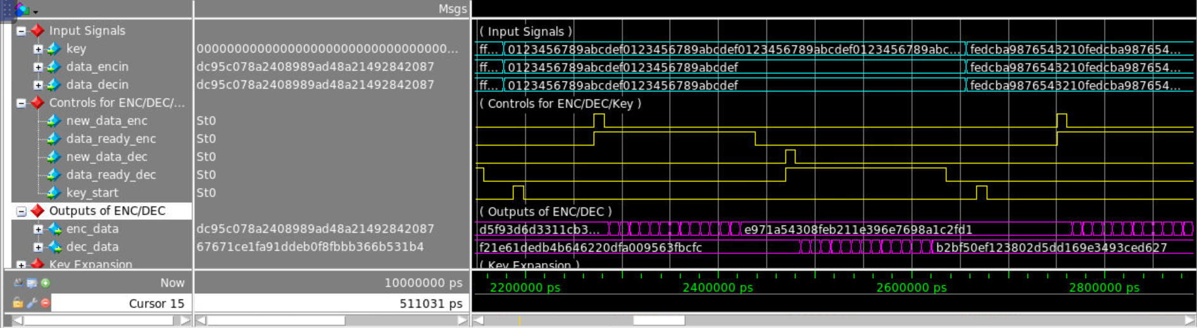

*Figure 56: Sample Test Cases*

The general order of test cases for the AES module follows this procedure:

1. If the key is new, the key_start signal is raised for 1 clock to expand the key for both processes - an appropriate 4 clock cycles passes to allow for complete expansion of all key-words.
2. The encryption signals (new_data_enc & data_ready_enc) are raised and lowered for 15 clock cycles - 1 to reset the round counters and 14 to process the data input to the module.
3. The decryption signals (new_data_dec & data_ready_dec) are raised and lowered for 15 clock cycles - 1 to reset the round counters and 14 to process the data input to the module.

This same procedure is followed for every test case. The inputs and keys are tied to both devices for each test case to make comparison easier. The current inputs being processed are the ones visible at the top (key, data_encin, and data_decin). These signals are processed as the control signals in yellow are raised. The final results are in purple and can be compared to the following screenshots of AES calculations:

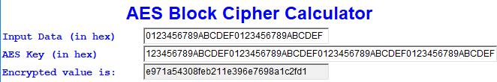

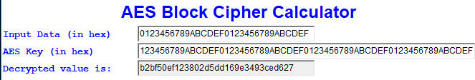

*Figure 57: Encryption & Decryption Results 1*

Following the procedure above, more test cases are provided below:

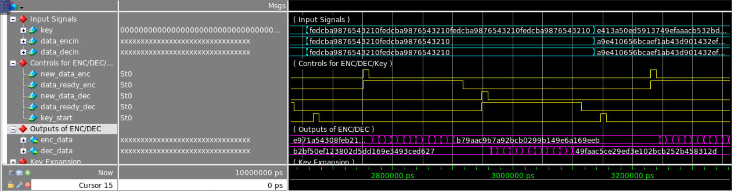

*Figure 58: Encryption & Decryption Operation 2*

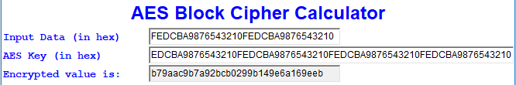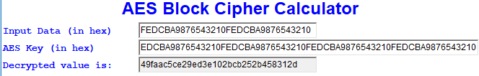

*Figure 59: Encryption & Decryption Results 2*

The following test is important to note that it is a feedback test. The description will be more in depth below:

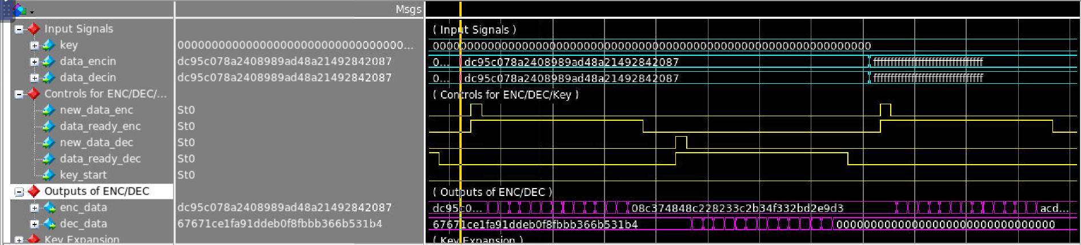

*Figure 60: Encryption & Decryption Feedback Test*

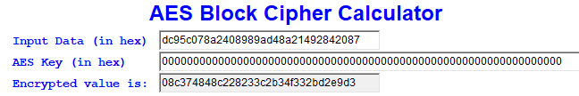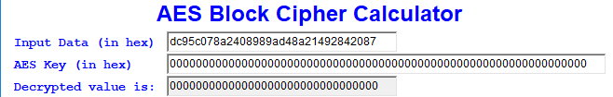

*Figure 61: Encryption and Decryption Feedback Results*

This test was generated in a specific manner. The AES module was ran using all 0’s as the input and the key (result: d95c078a2408989ad4821492842087). This encrypted output was then tied into both the encryptor and decryptor with the same key. The encryptor output a successful encrypted result, however the decryptor returned the all 0 input used to generate that result. This proves that the hardware can work in conjunction with one another.

More test cases for encryption and decryption are presented in the top level design to show more functionality as well as functionality in the top level.

**5.2.2 APB Protocol - APB_Protocol.sv**

**DSSC(s) Proven: 5**

The APB Protocol is used in the top level design as an interface between the user, the key register, and the results of both encryption and decryption. These results are all contained or will be stored in registers. In the individual test bench, a key register is used to show proper interfacing with other hardware. A sample interaction of all registers is shown in this test bench, however this protocol is much easier to verify in the top level. This is due to all registers being present and the signals being visible at an individual scale.

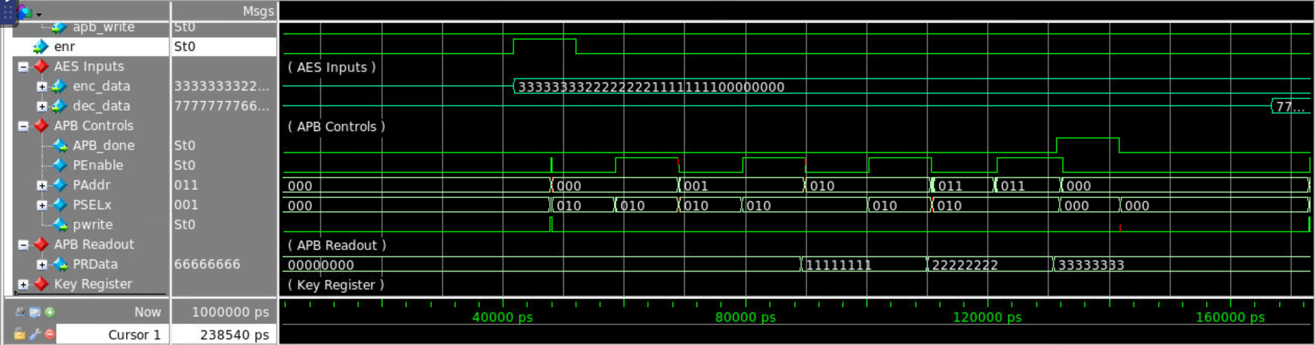

*Figure 62: APB Read from Encryption*

Here a sample read out from the encrypted register is performed. For a high level operational view, the following process is performed from the perspective of the entire top level design of our project:

1. The MCU determines a read request is made from the user (not shown)
2. The MCU examines the top level IO select line to determine to read out the encrypted or decrypted buffer (not shown)
3. The MCU finds the select line raised HIGH and raises the encryption read signal for 1 clock cycle and waits for an APB Done signal to reset (examine the enr signal for the MCU request).
4. From here, the first setup phase of encryption is performed. Some notable signal descriptions follow:
   1. PSELx is 3 bits long - 1 for each slave in the device. Upon the different requests received from the MCU, the following combinations indicate the corresponding active slave (For reference, PSELx remains 010 for this interaction):
      1. 100 - Key write slave
      2. 010 - Readout from Encryption slave
      3. 001 - Readout from Decryption slave
   2. Pwrite indicates the direction of the current interaction. It is raised high if data is being written and kept low if data is being read out of the protocol. In this interaction, data is being read out of the device and remains low.
   3. PAddr indicates what word address is being read out or written to in the current interaction. This address is incremented upon completion of every access phase of a transmission.
   4. PEnable is the signal that determines which phase the transmission is currently undergoing. When the signal is low during an active transfer, it indicates the device is in the setup phase. This gives the user 2 clock cycles to change their input data in write interactions or the device 2 clock cycles to settle the next address for reading out. Once raised, this indicates the device is in the access phase. Here, the data is updated or written in the read out or write ports, respectively.
   5. APB_Done serves as a reset signal for the MCU. Upon completion of any process, it is raised for one clock cycle.

Following this description, the enr signal is raised, indicating an encryption read. The device goes into encryption read mode, setting up the address and interaction with the enc_data port. It proceeds to cyclically read out the data from that port, LSB to MSB, in 32 bit segments. The PRData port can be examined to show the results of the readout interaction. Upon completion, the APB_Done signal is raised to reset the MCU.

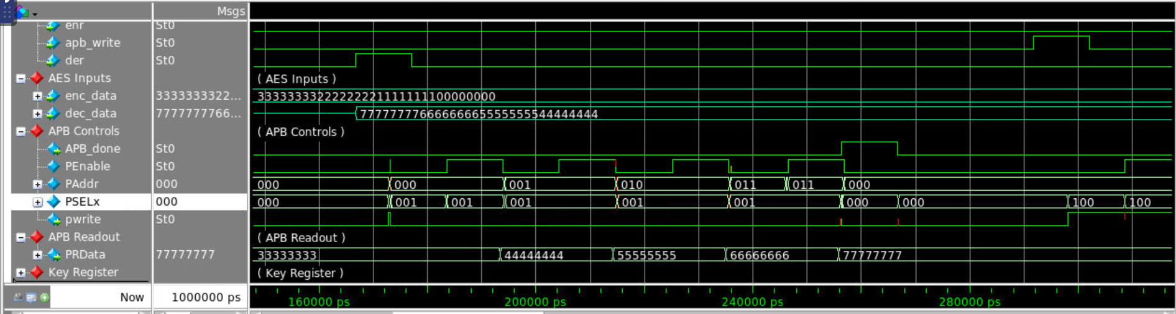

*Figure 63: APB Decryption Read Request*

The same type of interaction is performed for APB encryption readouts. Some notable differences are in the PSELx line, which is 001 to indicate the decryption readout slave is active, and the readout port (PRData) changes from the encrypted data to the decrypted data in the readout cycle. This shows that the device uses the same port to interface with 2 registers.

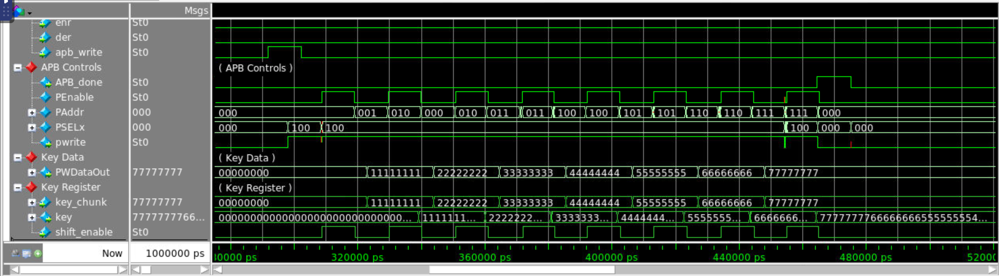

*Figure 64: APB Key Write Request*

The APB interaction differs slightly from the read interactions. Some notable differences are:

* The PSELx line is 100 to indicate a key write interaction
* PWrite is high during the transfer to indicate data is coming into the databus
* This transfer takes 8 setup-access cycles to complete the process. This is because 32 bits are written to the terminal at a time and 256 bits are needed for a complete key.

The key port in the key register group shows the key getting updated with new values as PEnable is high. Upon 8 cycles, the APB_Done signal is raised to reset the MCU into normal operation.

This test bench highlights the main functionality of the APB protocol, however there are more examples of interactions in the top level test bench of the entire design.

**5.2.3 USB Protocol and CRC Error Checking - usb_top.sv**

**DSSC(s) Proven: 3 & 4**

**5.2.3.1 Bidirectional Ports for D-plus / D-minus**

* DSSC(s) Proved: 3
* Method of testing:
  + For USB 1.1 Protocol, the D-plus & D-minus pins must be bidirectional. The direction of the pins are controlled by the external device that is currently interfacing with the USB protocol; sending a signal that will either keep the pins Hi-Z state or activate them to receive incoming data. Our test bench simulates the bidirectional pins by setting a signal high after a certain amount of time at which point the Hi-Z status the D-plus & D-minus pins started with changes to actively receiving.

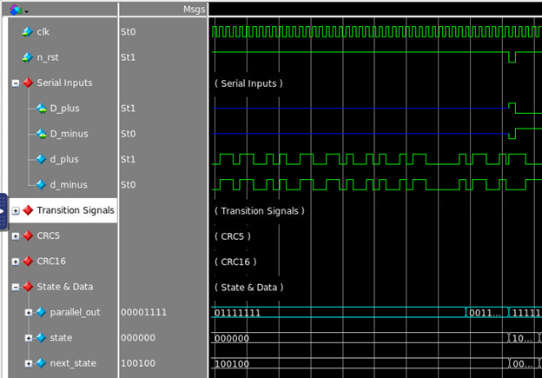Waveform:

*Figure 65: Bidirectional Ports for D-plus / D-minus*

The D-plus and D-minus signals are in Hi-Z state (blue wave extending from the serial inputs) until a signal from the test bench is set high and the waves change to actively receiving (green).

**5.2.3.2 Invalid Sync Byte**

* DSSC(s) Proved: 3
* Method of testing:
  + For USB 1.1 Protocol, at the beginning of every packet a sync byte must be received to show that the packet that is to be received is valid and prepared. To test, a forced error was sent through the test bench, sending a byte of all zeros when a sync byte should have been received.

Waveform:

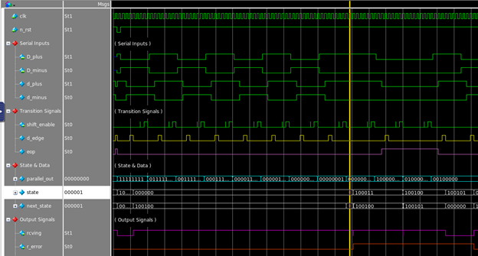

*Figure 66: Invalid Sync Byte*

In this scenario, the device is currently receiving the token packet, but the handling of receiving and invalid sync byte is handled in similar manner in every packet (token, data, or handshake). As seen in the parallel out at the cursor, which is placed on the sync byte check, the sync byte does not match the defined 10000000 and there for the devices enters an error state and the r-error flag is raised (in future tests, the valid sync byte is sent and continues the device operation).

**5.2.3..3 Invalid Token PID**

* DSSC(s) Proved: 3
* Method of testing:
  + As defined in section 2.3.2, we only accept one valid token packet IN-PID signaling that the data is coming into the device. To test this, a purposely invalid token ID is received.

Waveform:

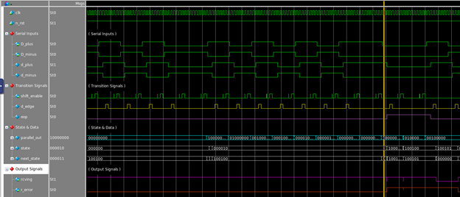

*Figure 67: Invalid PID*

After a successful sync byte reception, the next byte is checked to see if it matches the correct token PID. This device only uses in IN – PID (01101001 – 2.3.2) which signals incoming data as it is the devices only valid action. Any other byte received at this checkpoint will result in an error, as in this cases where the byte received is (10000000) which is not a valid token PID and the r-error flag is raised.

**5.2.3.4 Early EOP (end of packet)**

* DSSC(s) Proved: 3
* Method of testing:
  + An early end of packet flag is received and shifted in before the proper transmission of an entire packet (token, data, or handshake).

Waveform:

*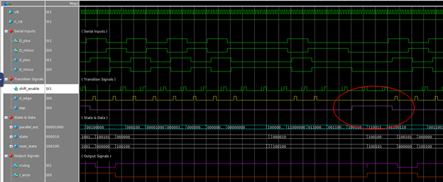Figure 68: Early End of Packet*

An early end of packet flag is received and shifted in during the reception of the token packet ID. When this occurs, the device enters an error state and awaits two d-edge flags to signal the beginning of the next reception. If an end of packet flag is ever received and shifted in early in any of the three packets (token, data, handshake) it results in a similar fashion, sending the device to the error state and awaiting two d-edge signals to begin the next reception.

**5.2.3.5 Invalid Token Address**

* DSSC(s) Proved: 3
* Method of testing:
  + An invalid 7-bit address and fist bit of the endpoints is sent to trigger an error in the reception of the token packet.

Waveform:

*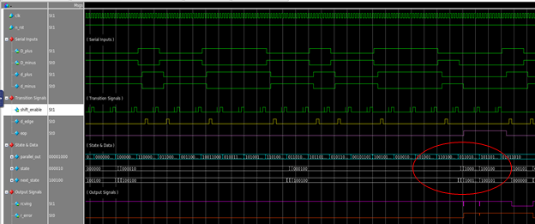Figure 69: Invalid Token Address and First Endpoint Bit*

As mentioned in section 2.3.2, the device only has one valid 7-bit address (0000000) which here is checked along with the first endpoint bit (again there is only one valid 4-bit endpoint 0000) and if this does not happen an error occurs.

**5.2.3.6 CRC5 Violation**

* DSSC(s) Proved: 3 & 4
* Method of testing:
  + A successful token sync byte, PID, address, and endpoints are sent in, but followed by an invalid CRC5 packet triggering an error.

Waveform:

*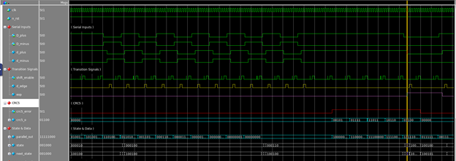Figure 70: CRC5 Violation*

At this point everything through the endpoints are valid (seen in the 0000 starting from the least significant bit of the parallel out) but the CRC5 fails as, since the address and endpoints are 11-bits of zeros, the CRC5 packet must all be zeros as well to pass the check. As can been seen, the CRC5 packet in this scenario is all ones which causes the check to fail, raising the CRC5 error flag and sending the device into an error state.

**5.2.3.7 Valid CRC5 and Late EOP Flag**

* DSSC(s) Proved: 3 & 4
* Method of testing:
  + A successful token sync byte, PID, address, endpoints, and CRC5 packet are received, but the end of packet signal is sent in late to trigger and error from the packet containing too much data and triggering and error.

Waveform:

*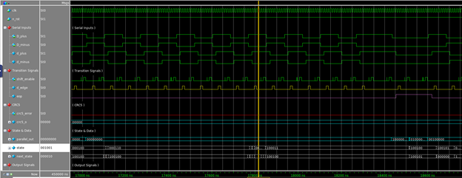Figure 71: Valid CRC5 and Late End of Packert*

After a successful reception of all the token packet information and CRC5 packet, the device will check to make sure an end of packet flag is sent shifted in before the next bit of information. If not, this signals that the token packet (or any other packet a late end of packet flag occurs) that the packet has too much data and therefore is an invalid packet. Sending the device into an error state where it awaits the end of packet signal and two d-edge signals before starting the next reception of data.

**5.2.3.8 Successful Token Packet Reception**

* DSSC(s) Proved: 3
* Method of testing:
  + A successful token packet is sent to be received to check if handled correctly.

Waveform:

*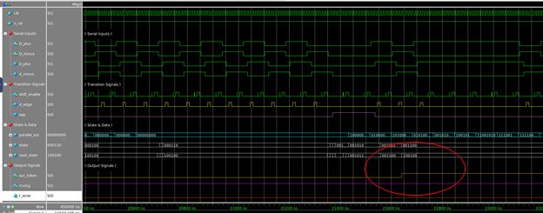Figure 72: Successful Token Packet Reception*

After a full successful token packet (valid sync byte, valid IN-PID, valid address, valid endpoints, successful CRC5 check, and no early or late end of packet flags), the device begins to receive the first byte of the data packet (the data packet’s sync byte) and raises the successful token flag to signal to the rest of the device that the token has been sent successfully.

**5.2.3.9 Invalid Data PID**

* DSSC(s) Proved: 3
* Method of testing:
  + An invalid data PID is sent to be received (neither the decode or encode ID) following a full successful token packet and a successful data packet sync byte.

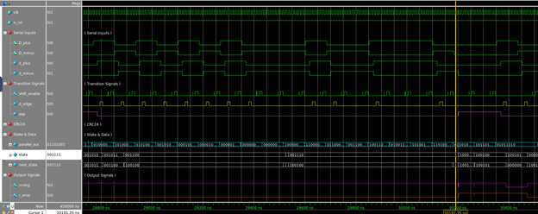Waveform:

*Figure 73: Invalid Data PID*

After a successful token packet, transition in to the Data Packet, and a valid sync byte, the device checks the second byte received in the data packet to see if it is a valid Data Packet ID. As mentioned in section 2.3.2, this device only registers two valid Data Packet IDs, and if it the second byte of the data packet does not match one of these (as seen here with the parallel out 10000000), the device enters and error state.

**5.2.3.10 Valid Decode Data PID, but Invalid Operational Byte**

* DSSC(s) Proved: 3
* Method of testing:
  + An invalid/mismatched operational byte (encryption) is sent to be received after the successful reception of a token packet, data packet sync, and data packet decode PID.

Waveform:

*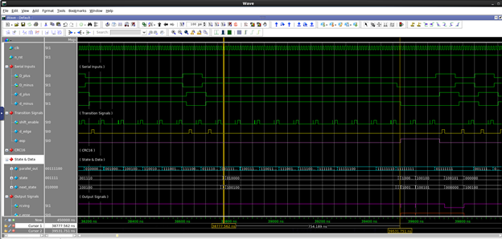Figure 74: Valid Decode Data PID and Invalid Operational byte*

A valid decode PID is received as seen at the left cursor (parallel out 00111100), but receives the defined encode operational packet (section 2.3.2), seen at the right cursor (parallel out 11111111), which causes the device to enter an error state as the only valid operational byte after receiving a decode PID is the encryption operational byte (the same goes for the encode PID, which requires and encryption operational byte to continue reception).

**5.2.3.11 Valid Encode Data PID and Valid Encryption Operational Byte**

* DSSC(s) Proved: 3
* Method of testing:
  + A successful Data encode PID followed by a successful Encryption Operational Byte are sent to be received following a successful Token Packet and Data sync byte.

Waveform:

*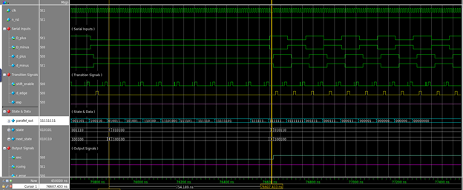Figure 75: Valid Encode Data Packet ID and Encryption Operational Byte*

Shown above is a successful encode data PID (left cursor: parallel out 01001101) followed by a successful encryption byte (right cursor: parallel out 11111111) which begins the reception of the following 128 bits of data and informs the MCU that it is to be encrypted by raising the enc signal.

**5.2.3.12 Valid Decode Data PID and Valid Decryption Operational Byte**

* DSSC(s) Proved: 3
* Method of testing:
  + A successful Data decode PID followed by a successful Decryption Operational Byte are sent to be received following a successful Token Packet and Data sync byte.

Waveform:

*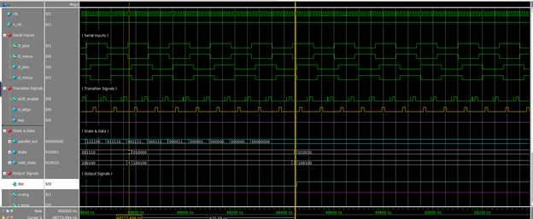Figure 76: Valid Decode Data Packet ID and Decryption Operational Byte*

Shown above is a successful decode data PID (left cursor: parallel out 00111100) followed by successful encryption byte (right cursor: parallel out 00000000) which begins the reception of the following 128 bits of data and informs the MCU that it is to be decrypted by raising the dec signal.

**5.2.3.13 CRC16 Error**

* DSSC(s) Proved: 3
* Method of testing:
  + A forced incorrect CRC16 packet is sent to be received after a successful token packet and data packet through the 136-bit payload to check to make sure an error flag is raised.

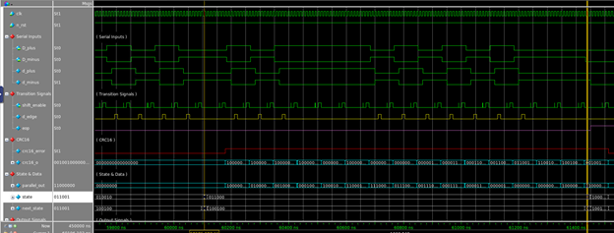Waveform:

*Figure 77: CRC16 Error Waveform*

After a full data packet reception of all zeros, a forceful incorrect CRC16 packet is transmitted through the test bench to produce an error. The left cursor shows when the CRC16 packet begins and the right cursor shows the value of the CRC16 output and error flag being raised accordingly.

**5.2.3.14 Successful CRC16 and Successful Data Packet Reception**

* DSSC(s) Proved: 3
* Method of testing:
  + A successful reception through the full data packet is sent which should result in the reception phase to move on to the handshake packet states.

Waveform:

*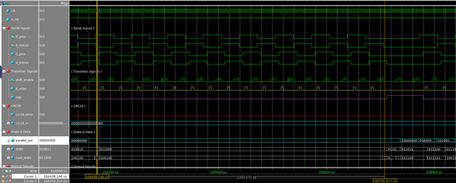Figure 80: Successful CRC16 and Successful Data Packet Reception*

After a full data packet reception of all zeros (left cursor), a successful CRC16 packet of all zeros is received and produces no error (right cursor). After this, the device must shift in a end of packet flag before the next bit to signal that the packet has concluded correctly and this occurs sending the device to wait for two d-edge signals before the reception of the Handshake Packet.

**5.2.3.15 Invalid Handshake PID**

* DSSC(s) Proved: 3
* Method of testing:
  + After a successful reception through the full data packet is completed along with the successful reception of the handshake sync byte, an invalid handshake PID is sent to be received.

Waveform:

*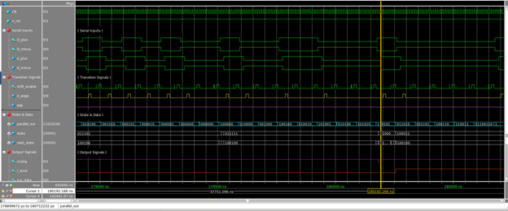Figure 81: Invalid Handshake ID*

After a successful sync transmission (as seen in the figure XXX) a successful Handshake PID must be received. Again, like the other PIDs for the other packet types, there are multiple different Handshake PIDs in USB 1.1 Protocol, but we only accept one valid PID, the ACK or Acknowledge Packet (11010100). Since this is not received the device enters an error state.

**5.2.3.16 Successful Transmission of the Handshake Packet**

* DSSC(s) Proved: 3
* Method of testing:
  + A successful complete transmission is received through all three packet types which should cause a flag to raise signaling the reception process is complete.

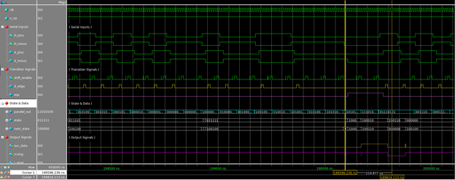Waveform:

*Figure 82: Successful Transmission of Handshake Packet*

With a successful reception of the Handshake PID (left cursor: parallel out 11010100) and an end of packet flag shifted in at the correct time, the handshake packet will be successfully received and the device will raise the successful data flag signaling to the MCU that encryption or decryption may begin.

**5.2.3.17 Bit Stuffing in CRC16 Packet**

* DSSC(s) Proved: 3
* Method of testing:
  + A valid data transmission is calculated to have a CRC16 with six ones in a row that should produce a stuffing-bit flag to be raised and cause the next shifted bit to be ignored by both the USB shift register and the CRC galois register.

Waveform:

*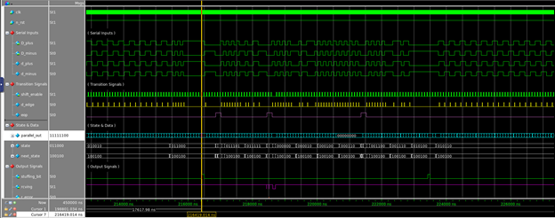Figure 83: Bit Stuffing in CRC16 Packet*

Above, a data packet has been received and a CRC16 packet is being received currently. At point marked by the cursor, six ones in a row have been shifted in causing the bit stuffing to trigger and the device to ignore the next bit shifting in. As seen, this does not affect the reception of the CRC16 packet (same for CRC5 Packet) as the bit is also ignored in its calculation and Galois Shift Register process.

**5.2.3.18 Bit Stuffing in CRC16 Packet**

* DSSC(s) Proved: 3
* Method of testing:
  + A valid data transmission of all 1-bits is calculated and sent to be received which should trigger multiple stuffing-bit flags to be raised during the data payload reception.

Waveform:

*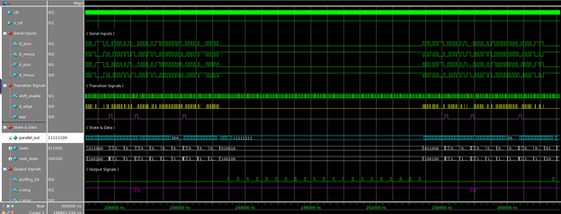Figure 84: Bit Stuffing Data Packet Waveform*

Bit Stuffing Data Packet – a data packet of all ones if being received and the stuffing bit flag is raised every six ones causing the shift register to ignore the next incoming bit for both the CRC Galois shift register check and the actual data being sent to the storage registers.

**5.2.3.19 Handling Short Packets - (for our device defined 136 bit payload)**

* DSSC(s) Proved: 3
* Method of testing:
  + A successful transmission through the operational byte of the data packet is sent to be received, followed by a data packet payload that is less than the device deficed 136-bits.

Waveform:

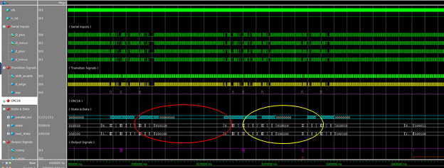

*Figure 85: Short Packet Size Comparison*

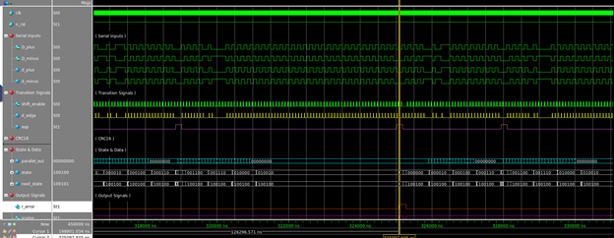

*Figure 86: Handling Short Packets*

In the figure 85 the red circle shows the size of a successful, correct data packet and the yellow circle shows the size of the short packet in question. Figure 86 shows a zoomed in image of the short packet and how it is handled. At the cursor, you see that an end of packet signal is raised (signaling the packet is supposed to be done) but our device only handles packets of 128 data bits plus 8 bits for the operational byte and since this signal occurs before the full 136 bits and the 16 bit of the CRC16 packet it sends the device into and error state (which can be seen with the r-error flag rising).

**5.2.3.20 Handling Long Packets - (for our device defined 136 bit payload)**

* DSSC(s) Proved: 3
* Method of testing:
  + A successful transmission through the decryption operational byte of the data packet is sent to be received followed by a data payload that is much longer than the device defined 136-bits.

Waveform:

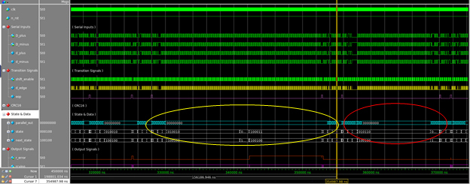

*Figure 87: Long Packet Comparison*

*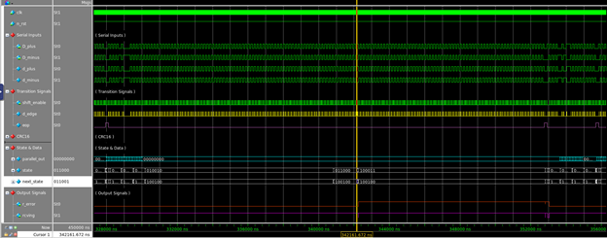Figure 88: Handling Long Packets*

Handling Long Data Packet – In Figure 87 the red circle shows the size of a successful data packet reception and the yellow circle shows the Long Packet in question. In figure 88, an image of the zoomed in long packet is shown. For this long packet, it is important to make note that it was tested using a stream of roughly 300 bits of zero. This is important because a too long stream of zeros being received beginning at the operational byte after a decode PID will successfully pass the decryption operational byte check as well as the CRC16 error check as the operational byte for decryption is eight zero bits and the correct CRC16 for any zero-bit data is sixteen bits of zero. Despite passing both checks, the device still enters an error state (which can be seen with the raising of the r-error flag at the cursor) due to failing to receive a correct end of packet flag. After a successful packet reception through the CRC5 or CRC16, or in the case of the handshake packet the successful PID, the device must shift in an end of packet flag before the next bit of data. In the case of the long packet, this does not happen causing the error to trigger and sending the device to an error state where it will await the end of packet signal.

**5.2.3.21 Full Successful Encryption Transmission Reception**

* DSSC(s) Proved: 3 & 4
* Method of testing:
  + A successful transmission containing the data encode PID and encryption operational byte is sent to be received which should successful demonstrate a full reception process for data to be encrypted.

Waveform:

*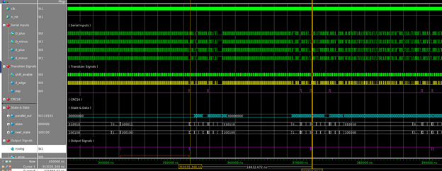Figure 89: Full Successful Encryption Transmission Received*

Figure 89 shows a full successful encryption transmission reception between the two cursors; the following images show the successful transmission of the Token Packet (Figure 90 – 94), Data Packet (Figure 95 – 100), and finally Handshake Packet (Figure 101).

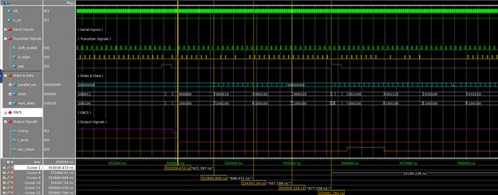

*Figure 90: Encryption Transmission - Token 1*

Figure 90: Highlighted cursor is placed on the beginning of the packet reception. A d-edge flag is raised which causes the transition beginning the reception and the rcving flag is raised to signal that the device has begun to receive data.

*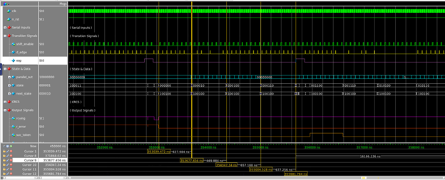Figure 91: Encryption Transmission - Token 2*

Figure 91: Highlighted cursor is placed on the sync byte check and as seen in in the parallel out (10000000) a successful sync byte has been received.

*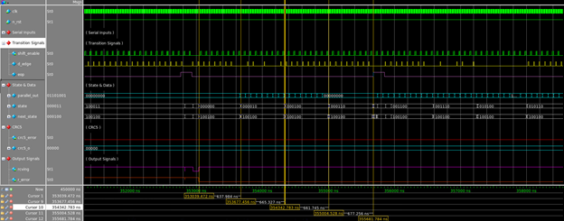Figure 92: Encryption Transmission - Token 3*

Figure 92: Highlighted cursor is placed on the token PID check and as seen in the parallel out (01101001) a successful token PID has been received.

*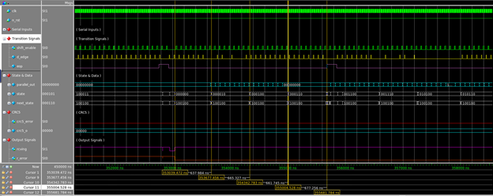Figure 93: Encryption Transmission - Token 4*

Figure 93: Highlighted cursor is placed on the on the token Address check (checks the 7-bit address and the first bit of the endpoints) and as seen in the parallel out (00000000) the address has been successfully received.

*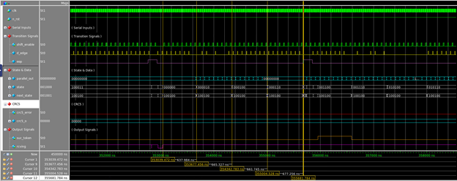Figure 94: Encryption Transmission - Token 5*

Figure 94: Highlighted cursor is placed on the token endpoint check (checks the last three bits of the endpoint) and as seen in the three least significant bits of the parallel out (000) the endpoints have been successfully received. Also, at this point, the CRC5 error flag is low which means the device has passed the CRC5 check as well. Following this, an end of packet flag is shifted in followed by two d-edge flags and the data packet begins to be received. The successful token flag is raised as well.

*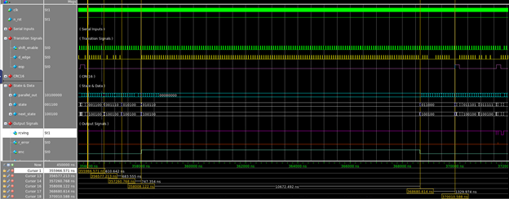Figure 95: Encryption Transmission - Data 1*

Figure 95: Highlighted cursor is placed on the beginning of the data reception where the second d-edge flag is received after the successful token packet reception.

*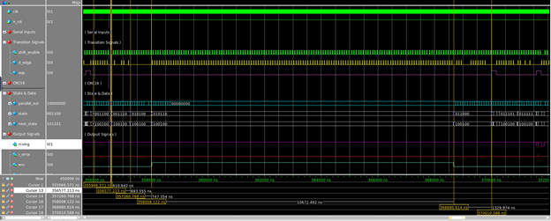Figure 96: Encryption Transmission - Data 2*

Figure 96: Highlighted cursor is placed on the Data Packet sync byte check and as seen with the parallel out (10000000), a successful sync byte has been received.

*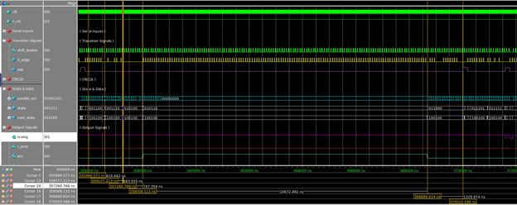Figure 97: Encryption Transmission - Data 3*

Figure 97: Highlighted cursor is place on the Data PID check and as seen in the parallel out (01001101) a successful Encode PID has been received.

*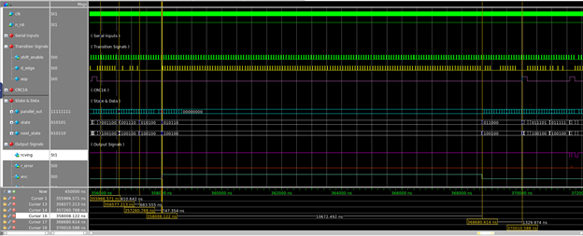Figure 98: Encryption Transmission - Data 4*

Figure 98: Highlighted cursor is placed on the Operational Byte Check and as seen in the parallel out (11111111) a successful Encryption operational byte has been received. With the successful encode PID and encryption operational byte, the enc flag is raised signaling to the MCU that the data is to be encrypted if the whole transfer is successful.

*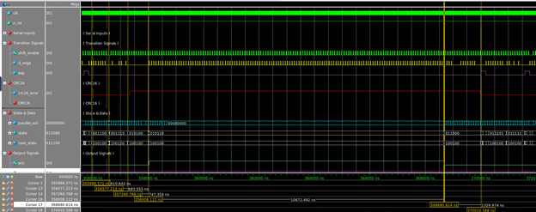Figure 99: Encryption Transmission - Data 5*

Figure 99: Highlighted cursor is placed on the end of the data transfer and the beginning of the reception of the CRC16 packet. At this point, the enc signal lowers signaling that no more data being received should be sent to be encrypted if the full reception is successful.

*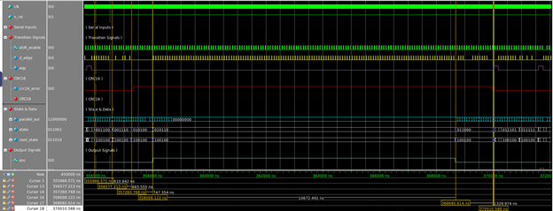Figure 100: Encryption Transmission - Data 6*

Figure 100: Highlighted cursor is placed on the CRC16 error check, and as seen, the CRC16 error flag is lowered signaling a successful data load and CRC16 packet reception. Following this, the end of packet flag is shifted in before another bit of data and two d-edge signals send the device into the Handshake Packet reception states.

*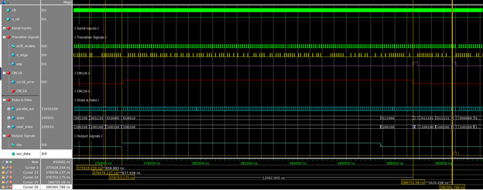Figure 101: Encryption Transmission - Handshake*

Figure 101: Highlighted cursor is placed on the handshake PID check and as seen in the parallel out (11010100) a successful PID has been received. After this, an end of packet flag has been shifted in followed by two d-edge flags signaling a completed successful full reception which raises the successful data flag signaling to the MCU that the encryption process may begin.

**5.2.3.22 Full Successful Decryption Transmission Reception**

* DSSC(s) Proved: 3 & 4
* Method of testing:
  + A successful transmission containing the data decode PID and decryption operational byte is sent to be received which should successful demonstrate a full reception process for data to be decrypted.

Waveform:

The process for a successful data reception for decryption is similar to the successful data reception for encryption reception process except for the decode data PID and the decryption operational byte.

*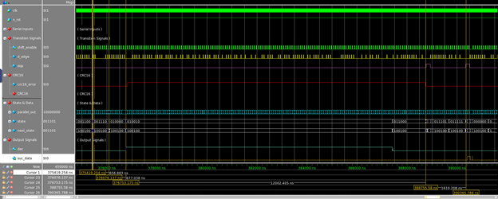Figure 102: Decryption Transmission - Data 1*

Figure 102: Highlighted cursor is placed on the sync check for the Data packet following a successful token packet reception. The parallel out (10000000) shows that a correct sync byte has been received.

*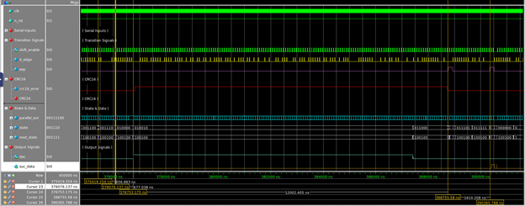Figure 103: Decryption Transmission - Data 2*

Figure 103: Highlighted cursor is placed on the Data PID check and as seen in the parallel out (00111100) a successful decode PID has been received.

*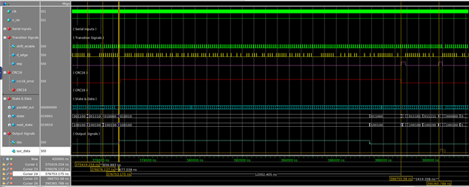Figure 104: Decryption Transmission - Data 3*

Figure 104: Highlighted cursor is placed on the Data operational byte check after a successful decode PID reception and as seen in the parallel out (00000000) a successful decryption operational byte has been received. This sends the dec signal to the MCU that the data is to be decrypted if the full reception is successful.

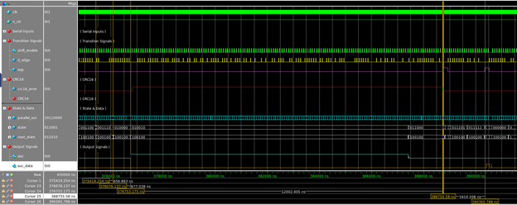

*Figure 105: Decryption Transmission - Data 4*

Figure 105: Highlighted cursor is placed on the CRC16 check and as seen, the CRC16 error flag is low signaling that the reception of the 136-bit data load and the following CRC16 packet were successful. Following this, and end of packet flag is shifted in before the next bit followed by two d-edges sending the device into the handshake reception states.

*Figure 106: Decryption Transmission - Handshake 1*

Figure 106: Highlighted cursor is placed on the handshake PID check and as seen in the parallel out (11010100) a successful PID has been received. After this, an end of packet flag has been shifted in followed by two d-edge flags signaling a completed successful full reception which raises the successful data flag signaling to the MCU that the decryption process may begin.

**5.2.3.23 CRC5 Error Checking**

* DSSC(s) Proved: 4
* Method of testing:
  + Ran multiple test cases where the CRC5 galois shift register was sent 11-bits of data (similar to what it validates in the token packet) followed by the correctly calculated CRC5 packet and a second case with an incorrect CRC5 packet (below are three of the test cases).

Waveform:

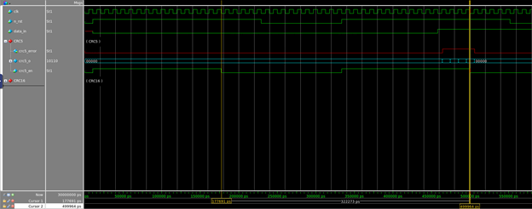  
*Figure 107: CRC5 Handling Testing 1*

Tested the CRC5 check for the reception of 11-bits of zero. The cursor on the left shows the location of the completed CRC5 packet with the correct CRC5 (00000) and the cursor on the right shows location of the completed CRC5 packet with the incorrect CRC5 (01111) which raises and error at this point.

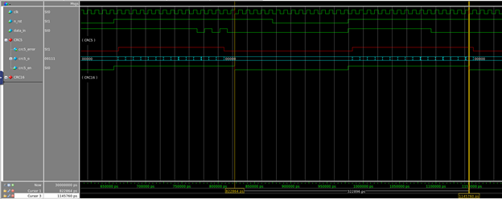

*Figure 108: CRC5 Handling Testing 2*

Tested the CRC5 check for the reception of 11-bits of one. The cursor on the left shows the location of the completed CRC5 packet with the correct CRC5 (01010) and the cursor on the right shows location of the completed CRC5 packet with the incorrect CRC5 (00000) which raises and error at this point.

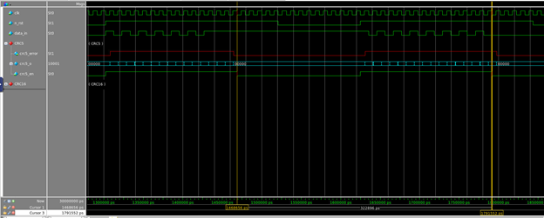

*Figure 109: CRC5 Handling Testing 3*

Tested the CRC5 check for the reception of binary 10101010101. The cursor on the left shows the location of the completed CRC5 packet with the correct CRC5 (01111) and the cursor on the right shows location of the completed CRC5 packet with the incorrect CRC5 (01010) which raises and error at this point.

**5.2.3.24 CRC16 Error Checking**

* DSSC(s) Proved: 4
* Method of testing:
  + Ran multiple test cases where the CRC16 galois shift register was sent 136-bits of data (similar to what it validates in the data packet) followed by the correctly calculated CRC16 packet and a second case with an incorrect CRC16 packet (below are three of the test cases).

Waveforms:

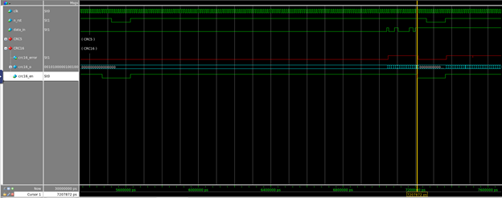

*Figure 110: CRC16 Handling Testing 1 - Incorrect*

Tested the CRC16 check for the reception of 136-bits of all zeros. The cursor marks the end of the reception of the CRC16 packet with the incorrect CRC16 (1000110000001101) which causes and error to be raised at this point.

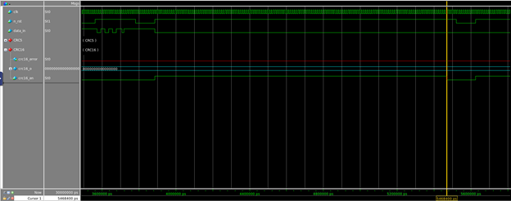

*Figure 111: CRC16 Handling Testing 1 - Correct*

Tested the CRC16 check for the reception of 136-bits of zero. The cursor marks the end of the reception of the CRC16 packet with the correct CRC16 (0000000000000000) which causes no error to be raised.

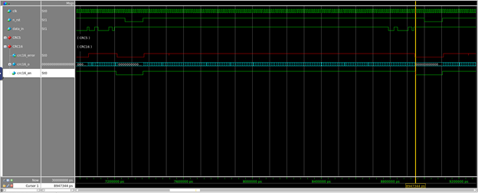

*Figure 112: CRC16 Handling Testing 2 - Correct*

Tested the CRC16 check for the reception of 136-bits of ones. The cursor marks the end of the reception of the CRC16 packet with the correct CRC16 (1000110000001101) which causes no error to be raised.

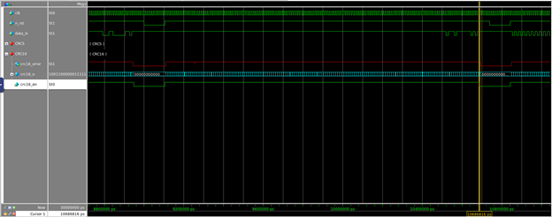

*Figure 113: CRC16 Handling Testing 2 - Incorrect*

Tested the CRC16 check for the reception of 136-bits of all ones. The cursor marks the end of the reception of the CRC16 packet with the incorrect CRC16 (0111011111110101) which causes and error to be raised at this point.

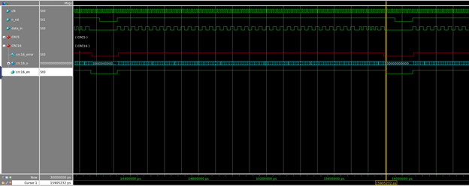

*Figure 114: CRC16 Handling Testing 3 - Correct*

Tested the CRC16 check for the reception of hex C * 34. The cursor marks the end of the reception of the CRC16 packet with the correct CRC16 (0101101010100110) which causes no error to be raised.

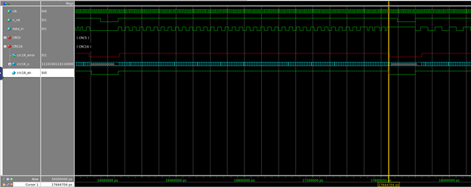

*Figure 115: CRC16 Handling Testing 3 - Incorrect*

Tested the CRC16 check for the reception of hex C * 34. The cursor marks the end of the reception of the CRC16 packet with the incorrect CRC16 (1111011011101101) which causes and error to be raised at this point.

**5.2.4 Top Level Design - Final_Project_top.sv**

**DSSC(s) Proven: 1, 2, 3, 4, 5, & 6**

A flow chart is provided below to demonstrate the intended functionality of the top level design:

*Figure 116: Operational Flowchart of Final_Project_top*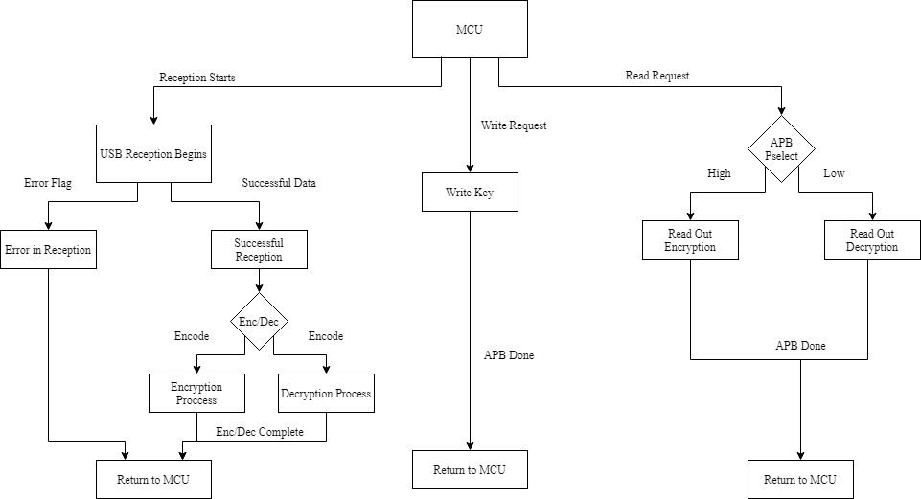

This diagram will highlight the main branches of functionality in the top level design. Starting from the MCU wait state, there are three main branches: read requests, write requests, and reception of data.

**Read Request** - Upon a read request from the top level IO, the design examine the current value of the select line. Depending on which value it is upon examination, it will initiate a read from the appropriate register to the APB protocol. Upon completion of either, it will send an APB_Done signal to reset the MCU to its idle state.

**Write Request** - Upon a write request from the top level IO, the MCU will initiate a write transfer through the APB protocol into the key register in the design. Upon completion, it will send an APB_Done signal to reset the MCU to its idle state.

**USB Reception** - Once data is sent through the serial lines of the USB protocol, the MCU will wait for the valid transmission of a token packet and determine the direction of data into the design. It will then serially receive the data and store it in the appropriate register. At any point there is an error, the data is considered void and the MCU is reset after the packet is ended. Upon a successful reception of all packets, the MCU will start either the encryption or decryption process, depending on the direction specified by the transmission. Error or not, at the end of this the MCU will reset into its idle state.

**DSSC(s) Highlighted: USB, CRC, & Top Level**

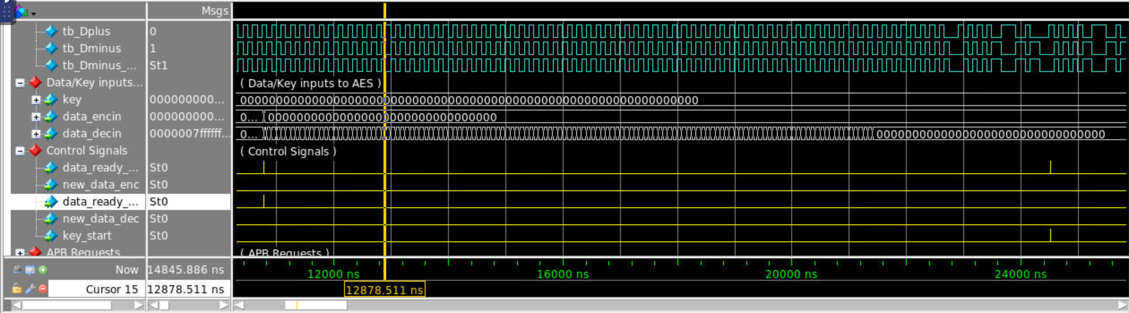

*Figure 117: Invalid CRC, USB Storing, & MCU Error Handling*

The first test cases for the top level design are all of the test cases that cause errors in the USB protocol. The purpose was to highlight how our MCU handles errors from USB Reception. In this case, the USB protocol will raise an error flag during its transmission. At any given point that the USB errors in its transmission, the MCU will go to an error state, where it will wait for an end of packet signal to reset to its idle state. This forces the MCU to ignore any data unless a valid order of transmission is followed.

Starting from the left, the USB receives a valid token packet and operational byte in its data payload. This determines that the data that follows is for decryption. The proper routing and storing internal signals are raised, and the data is slowly shifted into the data register for decryption. This is shown in data_decin, a 128 bit register with no reset. Due to metastability and no reset, the register decayed to all 1’s, however the 0s from the data being received are also being shifted to replace that invalid data. Following the reception of all 128 bits, under normal transmission, the control signals in yellow for AES would start. However, there was a wrongfully calculated CRC for the data payload. This triggers an internal error, which prevents the decryption from starting and preserving the integrity of the results.

Therefore, this test case highlights error handling, the CRC error checking functionality, and the reception of data from the USB.

**DSSC(s) Highlighted: USB, AES Encryption, Top Level**

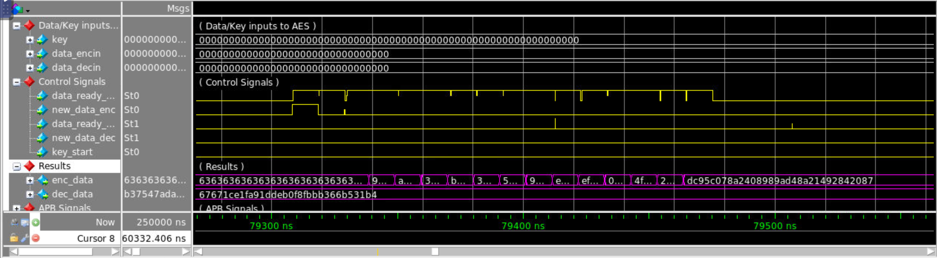

*Figure 118: Successful AES Encryption*

Here, the USB successfully receives a USB transmission that contained all 0’s for encryption. Upon successful reception, the MCU begins the encryption of data by using the control signals. Data_ready_enc serves as the AES round counter signal while the new_data_enc signal serves as the counter clear signal for the encryption process. Upon clearing, the clocks begin to increment 14 times. Upon reaching 14 clock cycles, the data is held constantly. Because the data received from the USB was determined to be valid, the result is also valid. Until more valid data comes through the USB transmission process to be encrypted, that result will remain constant to be read out by the APB protocol.

This test case highlights the encryption of the AES module in the top level, the ability to successfully receive data by the USB protocol and the capability of the MCU to chain these processes together. For validity, the following AES calculator screenshot is provided.

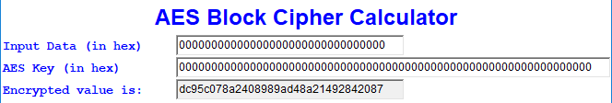

*Figure 119: AES Encryption in Top Level Result*

**DSSC(s) Highlighted: AES Decryption, USB, Top Level** 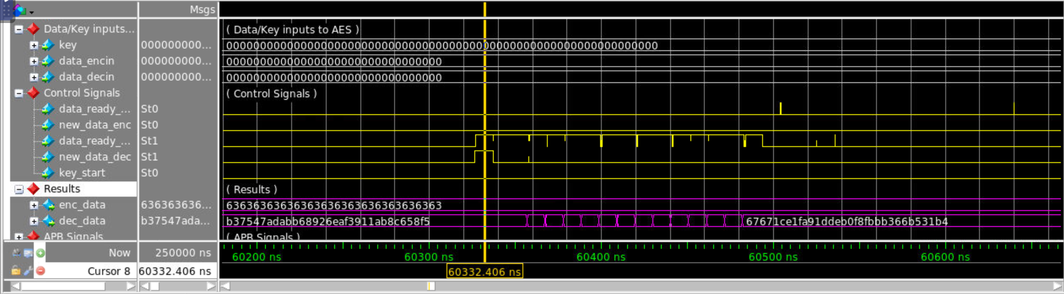

*Figure 120: AES Decryption Top Level*

The USB successfully receives a USB transmission that contained all 0’s for decryption. Upon successful reception, the MCU begins the decryption of data by using the control signals. Data_ready_dec serves as the AES round counter signal while the new_data_dec signal serves as the counter clear signal for the decryption process. Upon clearing, the clocks begin to increment 14 times. Upon reaching 14 clock cycles, the data is held constantly. Because the data received from the USB was determined to be valid, the result is also valid. Until more valid data comes through the USB transmission process to be decrypted, that result will remain constant to be read out by the APB protocol.

This test case highlights the decryption of the AES module in the top level, the ability to successfully receive data by the USB protocol and the capability of the MCU to chain these processes together. For validity, the following AES calculator screenshot is provided.

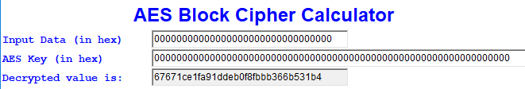

*Figure 121: AES Decryption Result for Top Level*

**DSSC(s) Highlighted: AES Decryption, USB, Top Level**

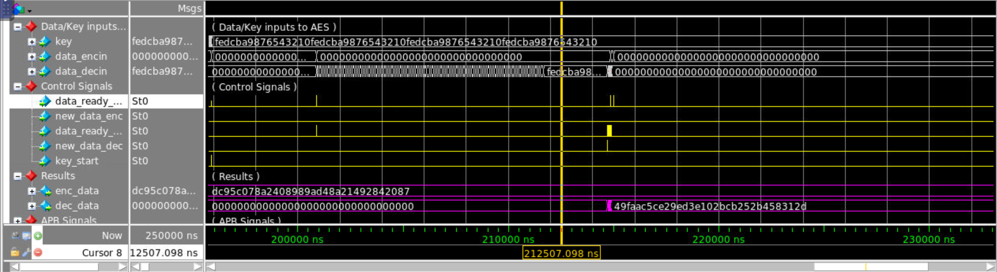

*Figure 122: USB Asymmetric Encryption*

This test case does not highlight any new functionality, however it does demonstrate the ability of the USB protocol to receive data much more than simply receiving a packet of all 0’s. Here, the USB packet receives the hexadecimal sequence FEDCBA9876543210 two times over for the 128 bit input. It also receives the data successfully, determining it is for decryption. It also uses that same sequence 4 times over for the key for the decryption. The control signals were minimized since they operate the same as in previous test cases.

This highlights the receiving capability of the USB protocol as well as demonstrates an asymmetric decryption in the top level. For validity, refer to the screenshot taken from the AES calculator below.

**

*Figure 122: Asymmetric AES Decryption Result*

**DSSC(s) Highlighted: APB Protocol, Top Level Design**

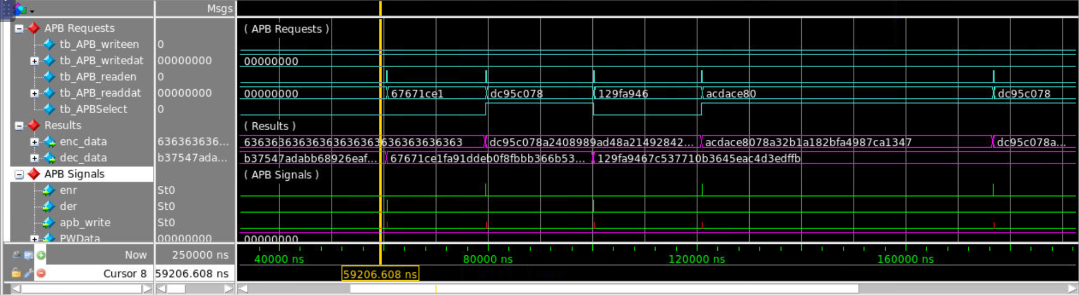

*Figure 123: APB Readout Overall Structure*

This test case is a zoomed out structure that highlights the top level IO in the APB Requests group. The impulse signals on the tb_APB_readen indicate that the user is making a readout requests. As per the operational waveform, the MCU will inspect the APBSelect line in the device to determine which register to use for the read out transmission (1 for encryption, 0 for decryption). This is shown by looking at the most significant 32 bits of both ports and matching them with the APB_readdat signal based on the value of APBSelect at that time. One readout will be inspected internally to confirm its functionality, however all interactions behave the same for the readouts.

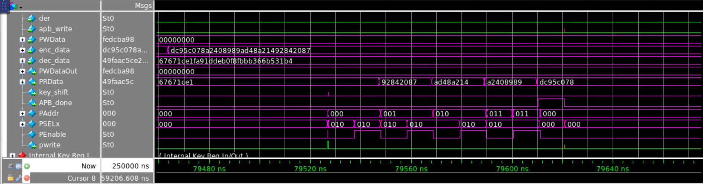

*Figure 124: APB Readout Internal Structure*

Here the internal signals in purple are the most important to inspect. A readout from encryption was signaled from the user, hence the value of 010 on the PSELx line. The setup-access cycle transfer begins, and the values shifted by the APB protocol can be compared with those from the enc_data port. After the 4 cycles are completed form the transfer, the APB_done signal is raised to reset the MCU. Also note the pwrite signal is kept low due to the outward direction of data in this transmission.

This test case highlights the APB Protocol readout function as well as its interfacing with the MCU signals based on the top level IOs for APB requests.

**DSSC(s) Highlighted: APB Protocol, Top Level**

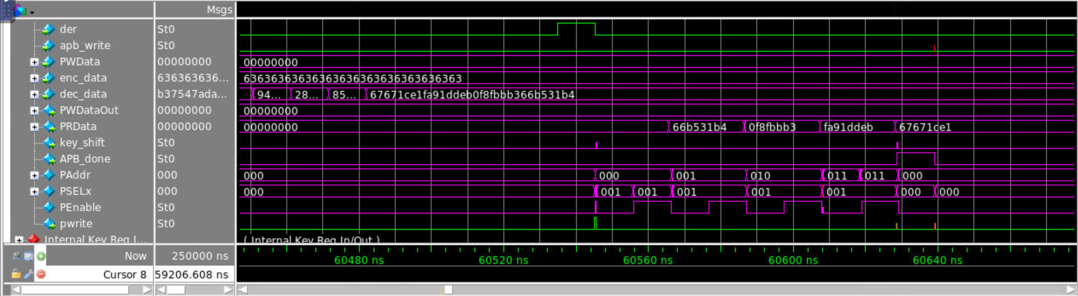

*Figure 125: APB Readout Decryption - Internal View*

This test case highlights the other possible readout interaction from the decryption port. The PSELx line remains 001 to indicate a readout from the decryption buffer is active. The PWrite signal remains low, indicating data is leaving through the APB Protocol. Finally, the data in the dec_data port is read out LSB first in 32 bit cycles, and the shifts in the PRData port reflect this transfer. The transfer is nearly identical to the encryption readout, save for some minor details in the design.

The DSSCs highlighted in this test are the APB Protocol readout interactions with the decrypted data register and how the MCU handles this request from the user.

**DSSC(s) Highlighted: APB Protocol, Top Level**

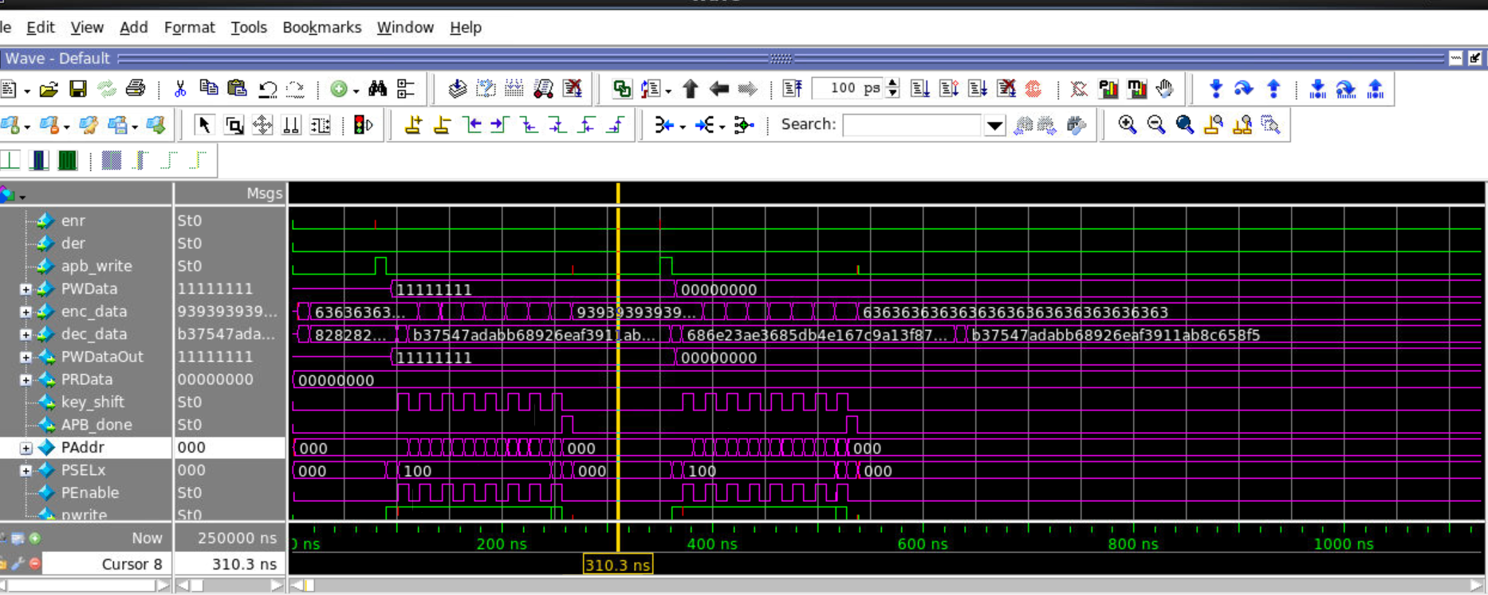

*Figure 126: APB Key Write Internal Structure*

This test case shows the internal signals of the key. Here, the apb_write signal generated from the MCU indicates there is an APB write key request from the user. Here, the PWData port is initialized by the user, which can be manipulated every 2 clock cycles to change what data is sent to the protocol. In this cast, there are 2 APB writes performed, one of all hexadecimal 1s, and another of all 0’s. Both protocols hold the PSELx line to 100 to indicate a key write is active. Also, the PWrite signal is held high during the transfer to indicate data is coming in from the protocol. Finally, 8 PEnable shifts are used for this transfer to complete since 256 bits are used for the key. At the end of both transfers, the APB_Done signals is raised to reset the MCU.

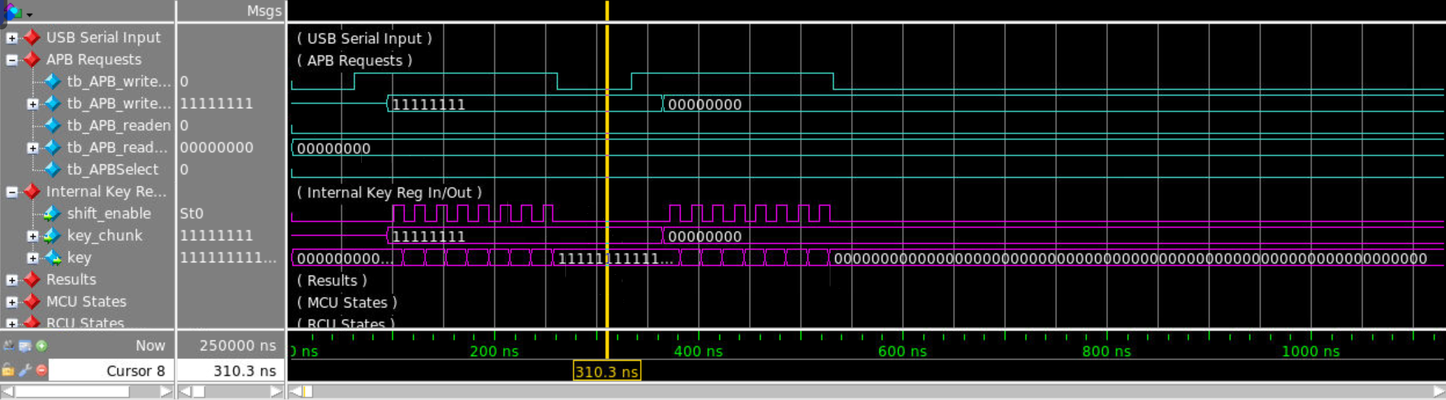

*Figure 127: APB Key Write - Key Register View*

This waveform snapshot is an extension of the same interaction shown in the previous waveform. This shows the signals in the key register, including the key register interface and the key changing values. At the end of both transfers, the key becomes all 0’s as intended.

This test case highlights the APB Protocol key write function as well as its interfacing with the MCU signals based on the top level IOs for APB requests.

**6. Project Management**

Joe 1) Designed the AES Encryption/Decryption Module

2) Tested the AES Encryption/Decryption Module

3) Designed the APB Protocol (W/ Zihan & Da)

4) Tested the APB Protocol (W/ Zihan & Da)

5) Designed the Top Level Module

6) Tested the Top Level Module (Joe (AES), Ben (USB), Zihan & Da (APB) )

7) Ran Innovus Layouts for Final Layout (W/ Ben)

Ben 1) Designed the USB Receiver Protocol

2) Tested the USB Receiver Protocol

3) Developed Tests USB Side for Top Level

4) Debugged the CRC Protocol for Synthesis

5) Tested the CRC Protocol (W/ Da)

6) Ran Innovus Layouts for Final Layout (W/ Joe)

Zihan 1) Designed the MCU Module

2) Tested the MCU Module

3) Designed the APB Protocol (W/ Joe & Da)

4) Tested the APB Protocol (W/ Joe & Da)

Da 1) Designed the CRC Module

2) Tested the CRC Module (W/ Ben)

3) Designed the APB Protocol (W/ Joe & Zihan)

4) Tested the APB Protocol (W/ Joe & Zihan)

**8. Appendix**

All files are located: mg92/ece337/Final_Project_Submission

**Design Verilog Code Modules:**

* **Top Level:**
  + **Top Level Modules:**
    - **Final Project Top Level:** source/Final_Project_top.sv
    - **Main Control Unit:** source/mcu.sv
    - **Key Register:** source/key_register.sv
    - **Data Register:** source/data_register.sv
    - **USB Receiver:** source/usb_top.sv
    - **AES Encryption/Decryption:** source/AES_Enc_Dec_top.sv
    - **APB Protocol:** source/APB_Protocol.sv
  + **Top Level Module Test Benches:**
    - **Final Project Top Level Test Bench:** source/tb_Final_Project_top.sv
    - **Main Control Unit Test Bench:** source/tb_mcu.sv
    - **Key Register Test Bench:** source/tb_key_register.sv
    - **Data Register Test Bench:** source/tb_data_register.sv
    - **USB Receiver Test Bench:** source/tb_usb_top.sv
    - **AES Encryption/Decryption Test Bench:** source/tb_AES_Enc_Dec_top.sv
    - **APB Protocol Test Bench:** source/tb_APB_Protocol.sv

* **USB 1.1 Receiver Protocol:**
  + **Protocol Modules:**
    - **Top Level:** source/usb_top.sv
    - **USB Control Unit:** source/rcu.sv
    - **USB Timers:** source/timer.sv
    - **Bit Stuffing Module:** source/bit_stuffing.sv
    - **CRC5 / CRC16 Verification:** source/crc_shift_register.sv
    - **NRZI Serial Input Decoder:** source/decode.sv
    - **D-plus Edge Detection:** source/edge_detect.sv
    - **End of Packet Detection:** source/eop_detect.sv
    - **D-orig Data Shift Register:** source/shift_reg_8_bit.sv
    - **Synchronous High:** source/sync_high.sv
    - **Synchronous Low:** source/sync_low.sv
  + **Protocol Module Testbenches:**
    - **Top Level Testbench:** source/tb_usb_top.sv
    - **Bit Stuffing Module:** source/tb_bit_stuffing.sv
    - **CRC5 / CRC16 Verification:** source/tb_crc_shift_register.sv
    - **NRZI Serial Input Decoder:** source/tb_decode.sv
    - **D-plus Edge Detection:** source/tb_edge_detect.sv
    - **End of Packet Detection:** source/tb_eop_detect.sv
    - **D-orig Data Shift Register:** source/tb_shift_reg_8_bit.sv
    - **Synchronous High:** source/tb_sync_high.sv
    - **Synchronous Low:** source/tb_sync_low.sv
  + **Component Sub Modules:**
    - **Flexible Counter:** source/flex_counter.sv
    - **Flexible Serial to Parallel Shift Register:** source/flex_stp_sr.sv
* **AES Modules**
  + **AES Top Level:**
    - **AES Top Level Module:** source/AES_Enc_Dec_top.sv
  + **Sub Modules:**
    - **Encryption Top Level:** source/AES_Encryption_top.sv
    - **Decryption Top Level:** source/AES_Decryption_Top.sv
    - **Key Expansion Top Level:** source/key_expand_top.sv
    - **Key Expand Control:** source/key_expand_enc.sv
    - **Key Expand Comb Logic:** source/key_expand.sv
    - **AES Decryption Stage:** source/AES_Stage_Dec.sv
    - **AES Encryption Stage:** source/AES_Stage_Enc.sv
    - **Bytewise S-Box Forward:** source/s_box_forward.sv
    - **Bytewise S-Box Inverse:** source/s_box_inverse.sv
    - **Byte Substitution:** source/byte_sub_enc.sv
    - **Inverse Byte Substitution:** source/inverse_byte_sub.sv
    - **Galois9 Notation:** source/Galois9.sv
    - **Galois11 Notation:** source/Galois11.sv
    - **Galois13 Notation:** source/Galois13.sv
    - **Galois14 Notation:** source/Galois14.sv
    - **Mix Columns:** source/mix_cols_enc.sv
    - **Inverse Mix Columns:** source/inverse_mix_columns.sv
    - **Shift Rows Encryption:** source/shift_rows_enc.sv
    - **Inverse Shift Rows:** source/inverse_shift_rows.sv
    - **Key Addition:** source/key_addition.sv
    - **Flex Counter:** source/flex_counter.sv
  + **AES Test Benches:**
    - **AES Top Level Test Bench:** source/tb_AES_Enc_Dec_top.sv
    - **Key Addition Test Bench:** source/tb_key_addition.sv
    - **AES Decryptor Test Bench:** source/tb_AES_Decryption_Top.sv
    - **AES Encryptor Test Bench:** source/tb_AES_Encryption_top.sv
    - **Byte Substitution Test Bench:** source/tb_byte_sub_enc.sv
    - **Galois14 Notation Test Bench:** source/tb_Galois14.sv
    - **Key Expansion Test Bench:** source/tb_key_expand_top.sv
    - **Mix Columns Encrypt Test Bench:** source/tb_mix_cols_enc.sv
    - **Shift Rows Encrypt Test Bench:** source/tb_shift_rows_enc.sv
* **APB Protocol:**
  + **APB Protocol Modules:**
    - **APB Protocol Top Structure:** source/APB_Protocol.sv
    - **APB State Machine:** source/apb_fsm.sv
    - **APB Shift Register:** source/APB_Reg.sv
    - **APB Read/Write Routing:** source/APB_Route.sv
  + **APB Protocol Test Benches:**
    - **APB Protocol Top Test Bench:** source/tb_APB_Protocol.sv

**Mapped Files:**

* **Top Level:**
  + **Top Level Mapped Files:**
    - **Final Project Top:** mapped/Final_Project_Top.v
    - **Key Register:** mapped/key_register.v
    - **Main Control Unit:** mapped/mcu.v
* **AES Encryption and Decryption**
  + **AES Mapped Files:**
    - **AES Top Level:** mapped/AES_Enc_Dec_top.v
    - **AES Encryption Top:** mapped/AES_Encryption_top.v
    - **AES Decryption Top:** mapped/AES_Decryption_top.v
    - **AES Decryption Stage:** mapped/AES_Stage_Dec.v
    - **AES Encryption Stage:** mapped/AES_Stage_Enc.v
    - **AES Key Expansion:** mapped/key_expand_top.v
* **APB Protocol:**
  + **APB Mapped Files:**
    - **APB Protocol Top Level:** mapped/APB_Protocol.v
* **USB Protocol:**
  + **USB Mapped Files:**
    - **USB Top level:** mapped/usb_top.v
    - **USB Bit Stuffing:** mapped/bit_stuffing.v
    - **USB CRC5 / CRC16:** mapped/crc_shift_register.v
    - **USB Decoder:** mapped/decode.v
    - **USB End of Packet Detection:** mapped/eop_detect.v
    - **USB Edge Detection:** mapped/edge_detect.v
    - **USB Control Unit:** mapped/rcu.v
    - **USB Shift Register:** mapped/shift_reg_8_bit.v
    - **USB High Sync:** mapped/sync_high.v
    - **USB Low Sync:** mapped/sync_low.v
    - **USB Timers:** mapped/timer.v

**Report Files:**

* **Verilog Modules Reports:**
  + **General Report Files:**
    - **Final Project Top Level:** reports/Final_Project_top.rep
    - **AES Top Level:** reports/AES_Enc_Dec_Top.rep
    - **AES Decryption Top Level:** reports/AES_Decryption_Top.rep
    - **AES Encryption Top Level:** reports/AES_Encyption_Top.rep
    - **AES Decryption Stage:** reports/AES_Stage_Dec.rep
    - **AES Encryption Stagel:** reports/AES_Stage_Enc.rep
    - **AES Key Expansion:** reports/key_expand_top.rep
    - **APB Protocol Top Level:** reports/
    - **USB Top Level:** reports/usb_top.rep
    - **USB Bit Stuffing:** reports/bit_stuffing.rep
    - **USB CRC5/CRC16 Galois Shift Registers:** reports/crc_shift_register.rep
    - **USB Decoder:** reports/decode.rep
    - **USB Edge Detection:** reports/edge_detect.rep
    - **USB End of Packet Detection:** reports/eop_detect.rep
    - **USB Control Unit:** reports/rcu.rep
    - **USB Shift Register:** reports/shift_reg_8_bit.rep
    - **USB High Sync:** reports/sync_low.rep
    - **USB Low Sync:** reports/sync_low.rep
    - **USB Timers:** reports/timer.rep
    - **Main Control Unit:** reports/mcu.rep
    - **Key Register:** reports/key_register.rep
    - **Flexible StP Shift Register:** reports/flex_stp_sr.rep
    - **Flexible Counter:** reports/flex_counter.rep
* **Innovus Report Files:**
  + **Timing Report:**
    - **All Post Route:** timingReports/Final_Project_top_postRoute_all.tarpt.gz
    - **(All other timing reports for the innovus simulation are under timingReports/...)**
  + **Innovus Layout Log:**
    - reports/innovus.logv2 (Connectivity, geometry, layout area contained here)

**Final Presentation:**

* **Final Presentation:** docs/ASIC_Final_Presentation

**Final Report:**

* **Final Report:** docs/Final_Report

**7. References**

(2016). *Modern Cryptography: Applied Mathematics for Encryption and Information Security*. Retrieved February 24, 2018, from <http://apprize.info/security/cryptography/9.html>

(2018). Rijndael MixColumns. Retrieved March 9th, 2018, from <https://en.wikipedia.org/wiki/Rijndael_MixColumns>

(2018). Peacock, C. (n.d). USB Protocols. Retrieved April 28, 2018, from <http://beyondlogic.org/usbnutshell/usb3.shtml>

(1998).Universal Serial Bus Specification. [ebook] pp.171 - 177. Available at: http://esd.cs.ucr.edu/webres/usb11.pdf [Accessed 2 May 2018].